Question 1: Explore chromosome X in Homo sapiens and find out the location of the MECP2 gene.

A.

I used Ensembl (<https://asia.ensembl.org/Homo_sapiens/Location/Genome>) database to explore the chromosome X from the homo sapiens species.

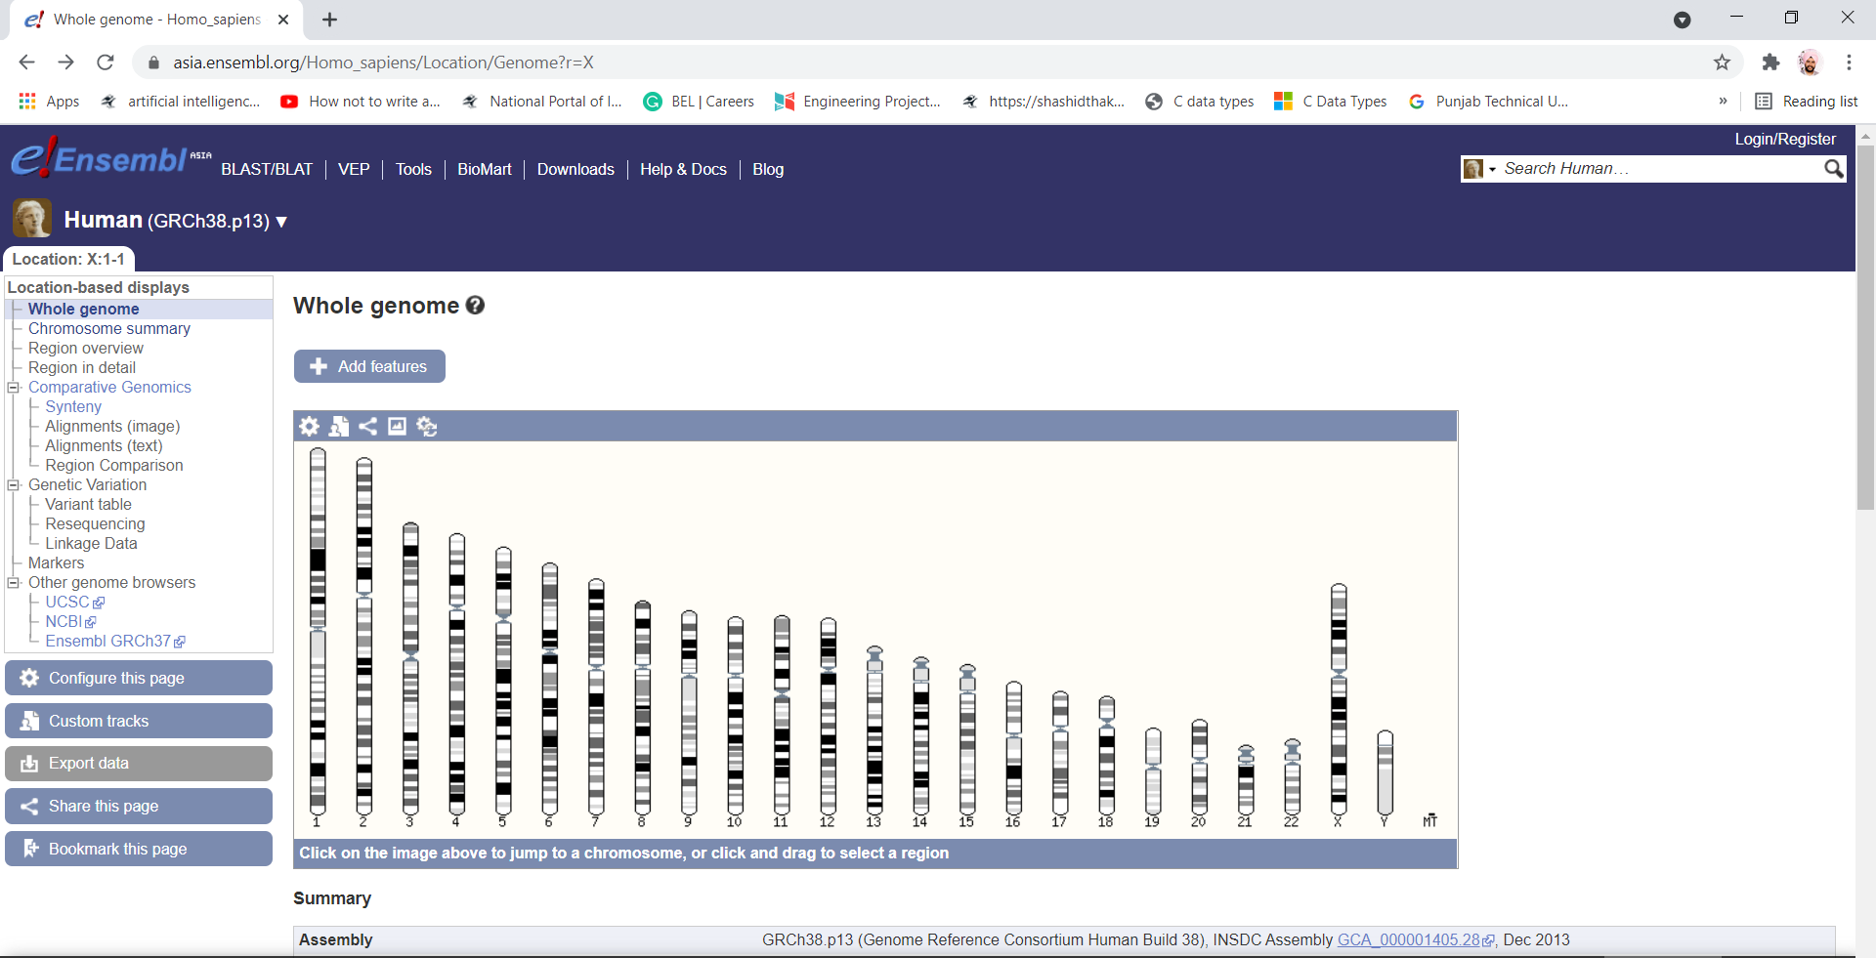

Figure 1 All Chromosomes of Homo sapiens species

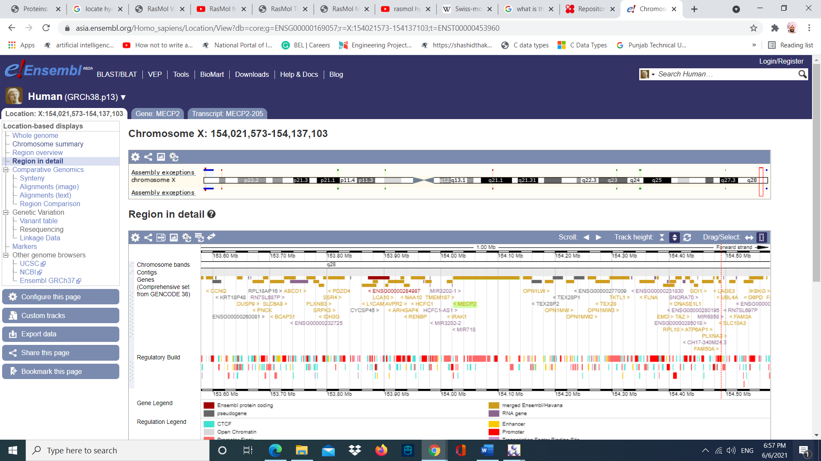

Figure 2 Homo sapiens species Chromosome X region

B.

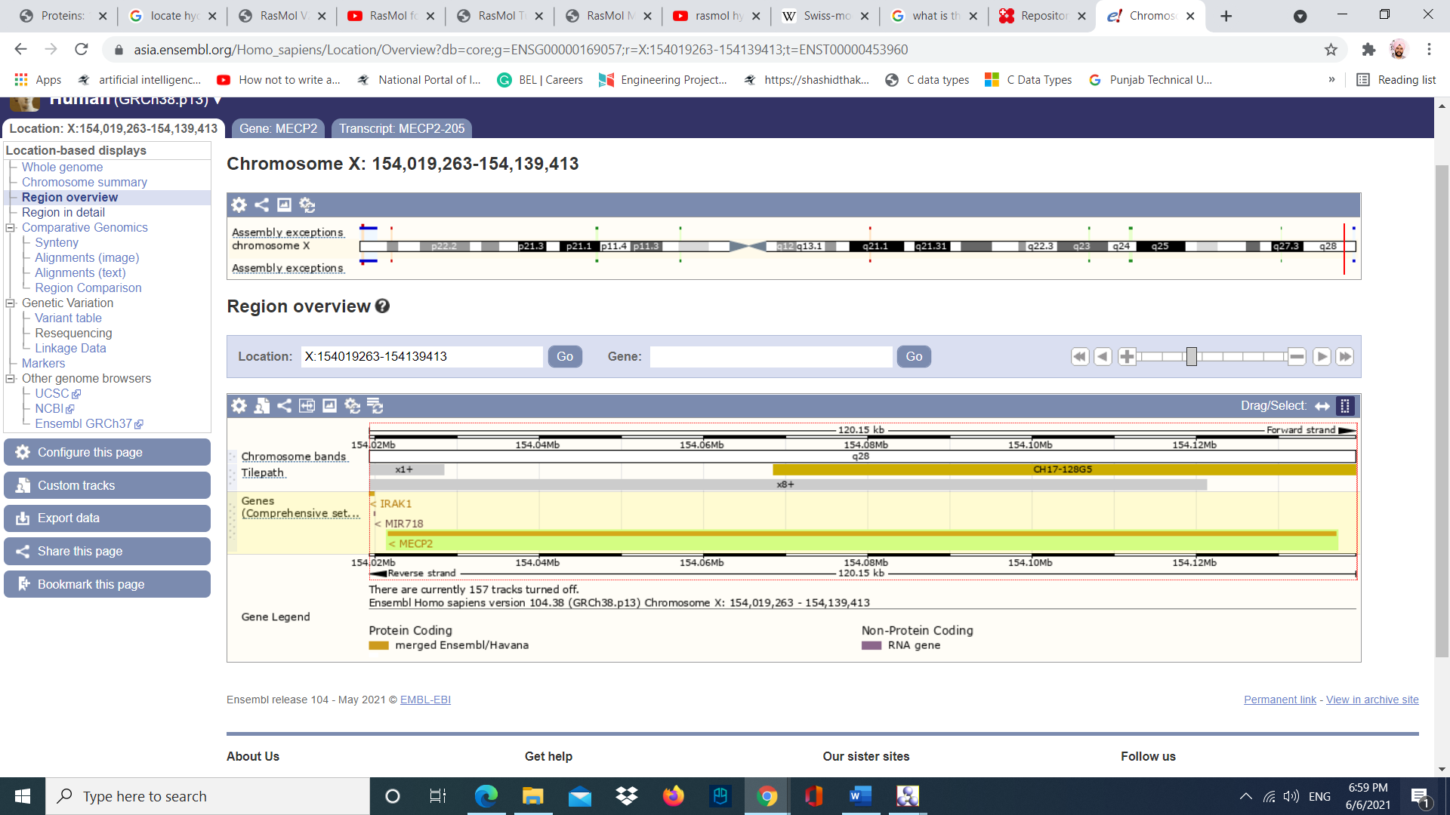

Figure MECP2 gene in the chromosome X

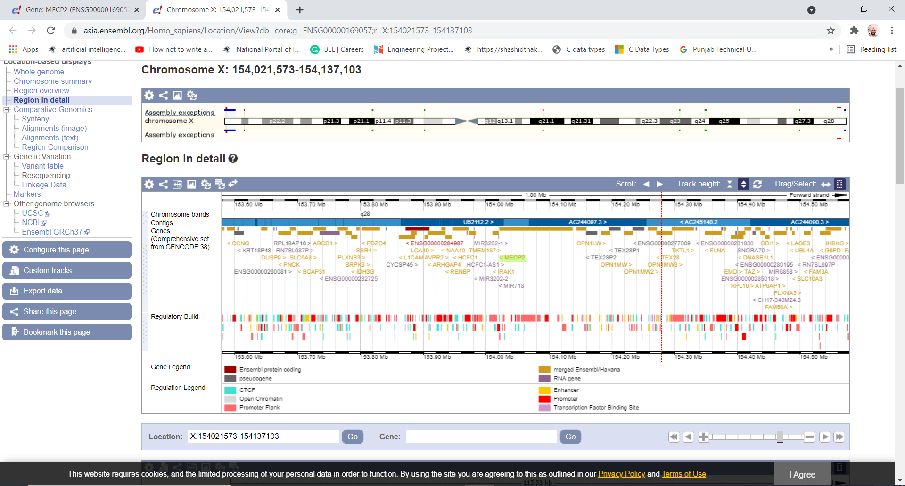

Figure MECP2 gene region in detail

C.

The location of the MECP2 gene in the chromosomal assembly is at Xq28.



Figure Location of MECP2 gene

D.

Coding regions of MECP2 gene.

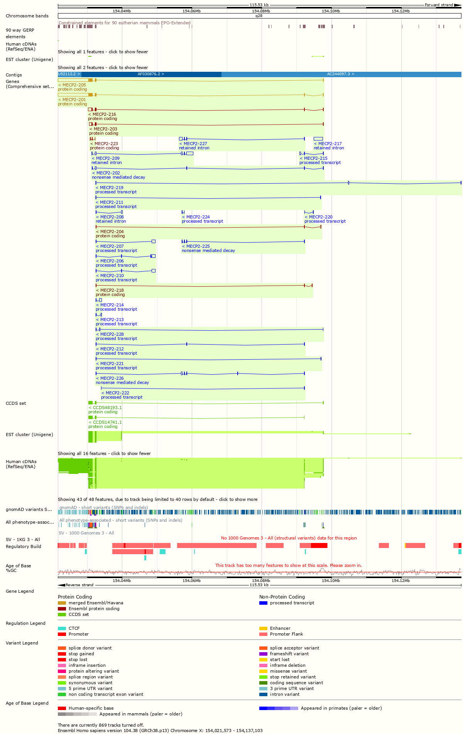

Figure Coding regions of MECP2

E.

I have selected MECP2-205 protein coding variant of the gene. This protein gene transcript has 3 exons. 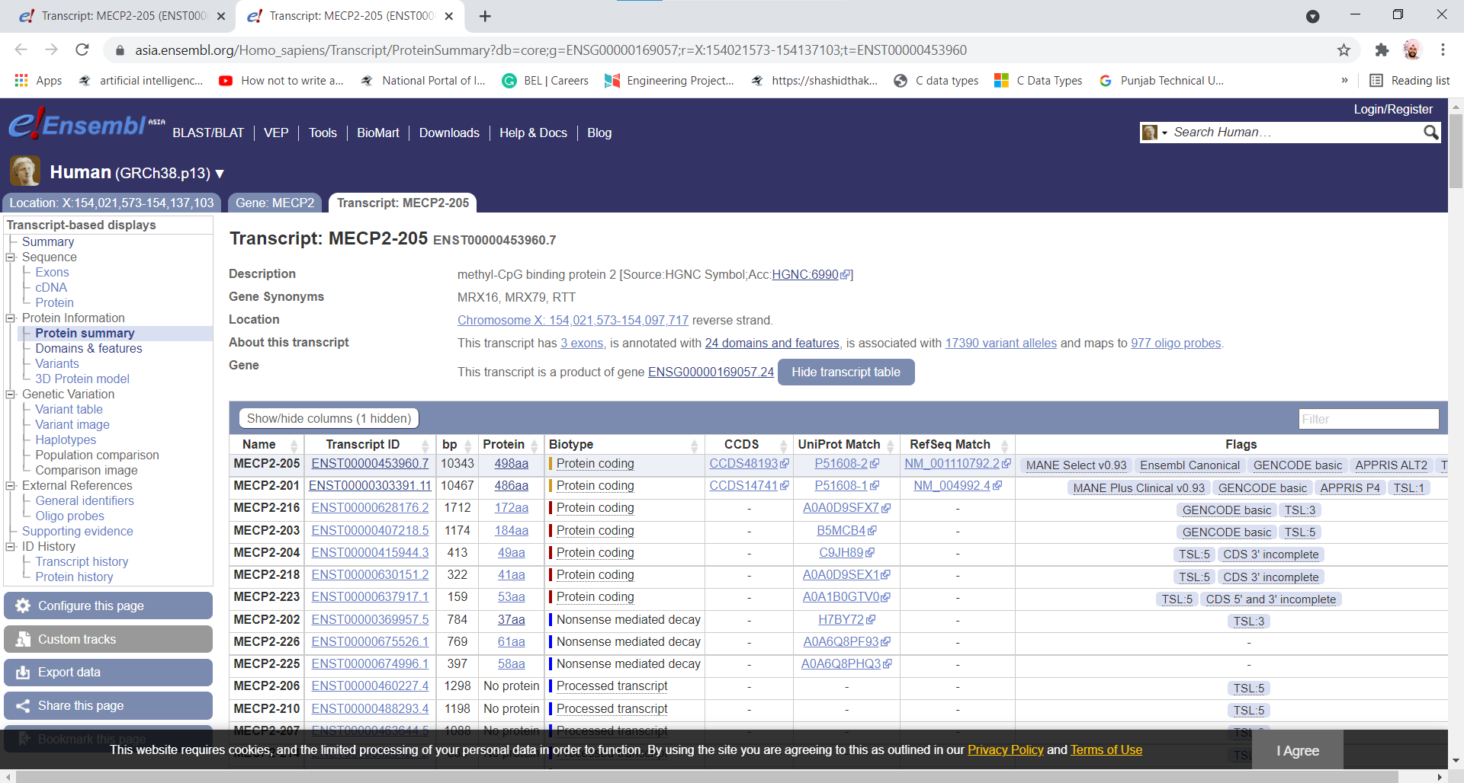

Figure Transcript table of MECP2 gene

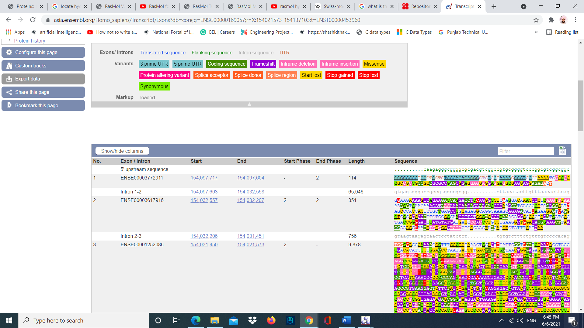

Figure Exons in MECP2-205 gene

F.

There are 198735 SNPs in the MECP2 gene. I located the SNPs of the MECP2 gene on Ensembl and UCSC genome browser.

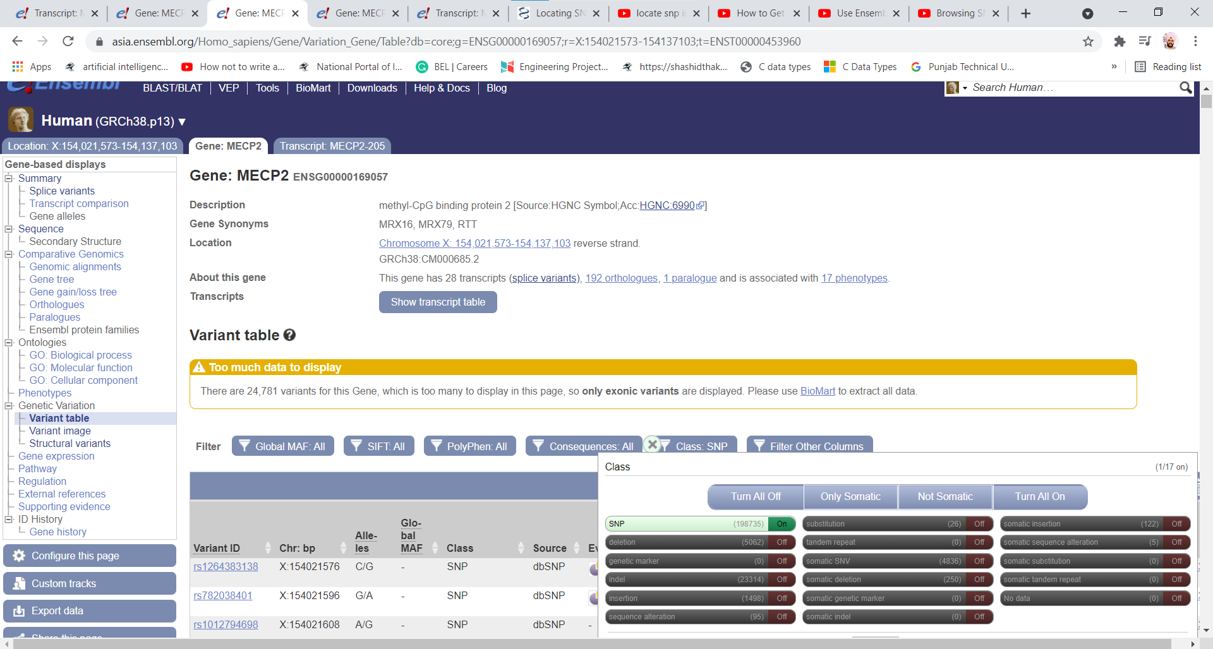

Figure SNPs table in Ensembl

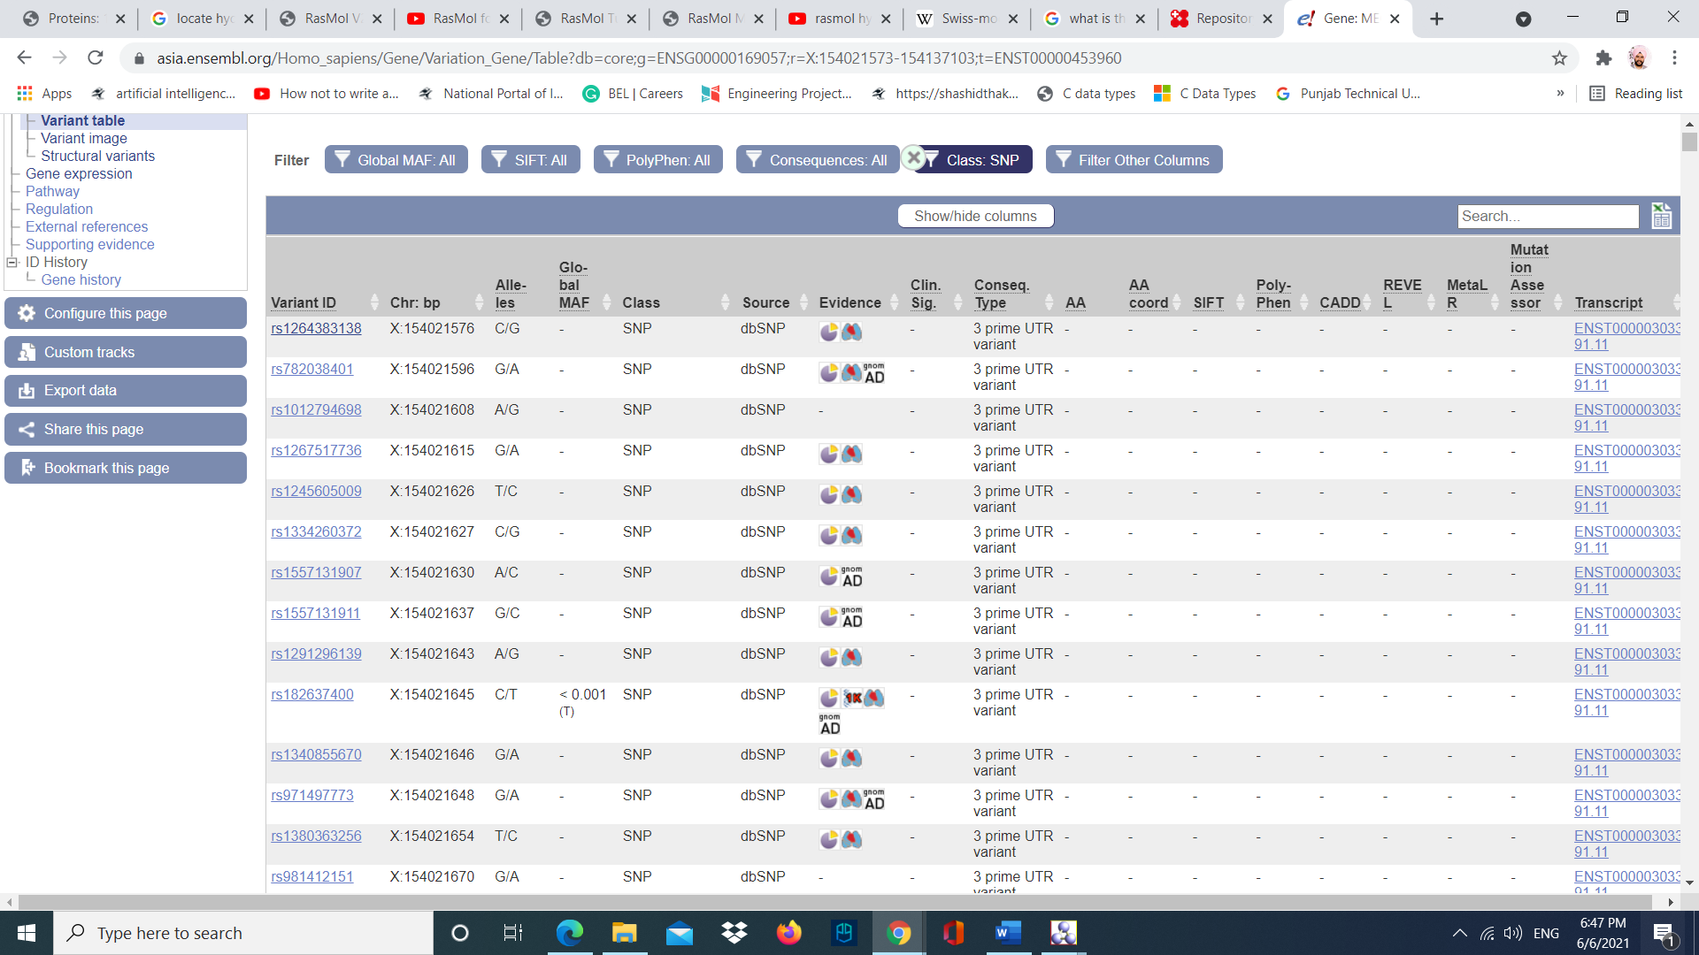

Figure SNPs list in Ensembl

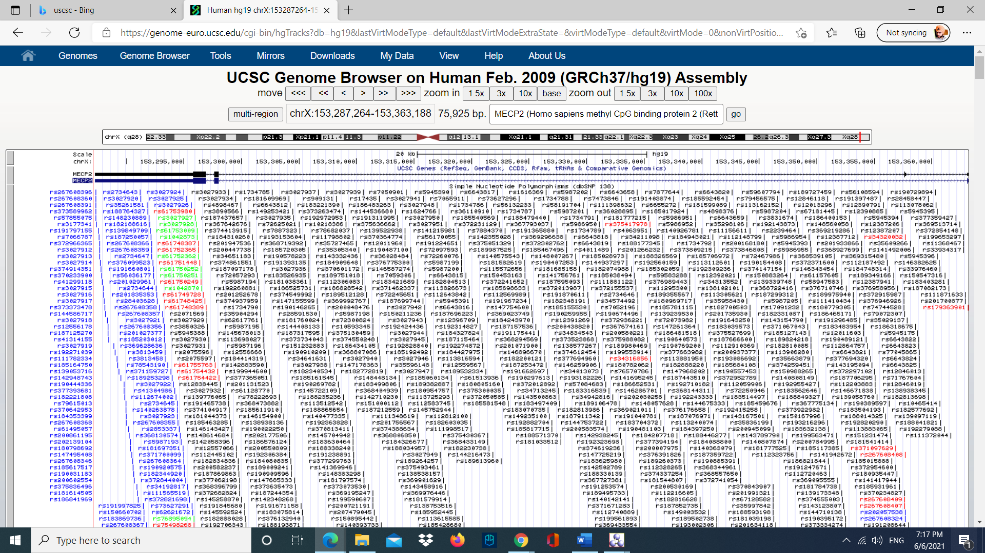

Figure SNPs in gene region in UCSC genome browser

Question 2: Explore the information you extracted from your allocated chromosome and gene.

A.

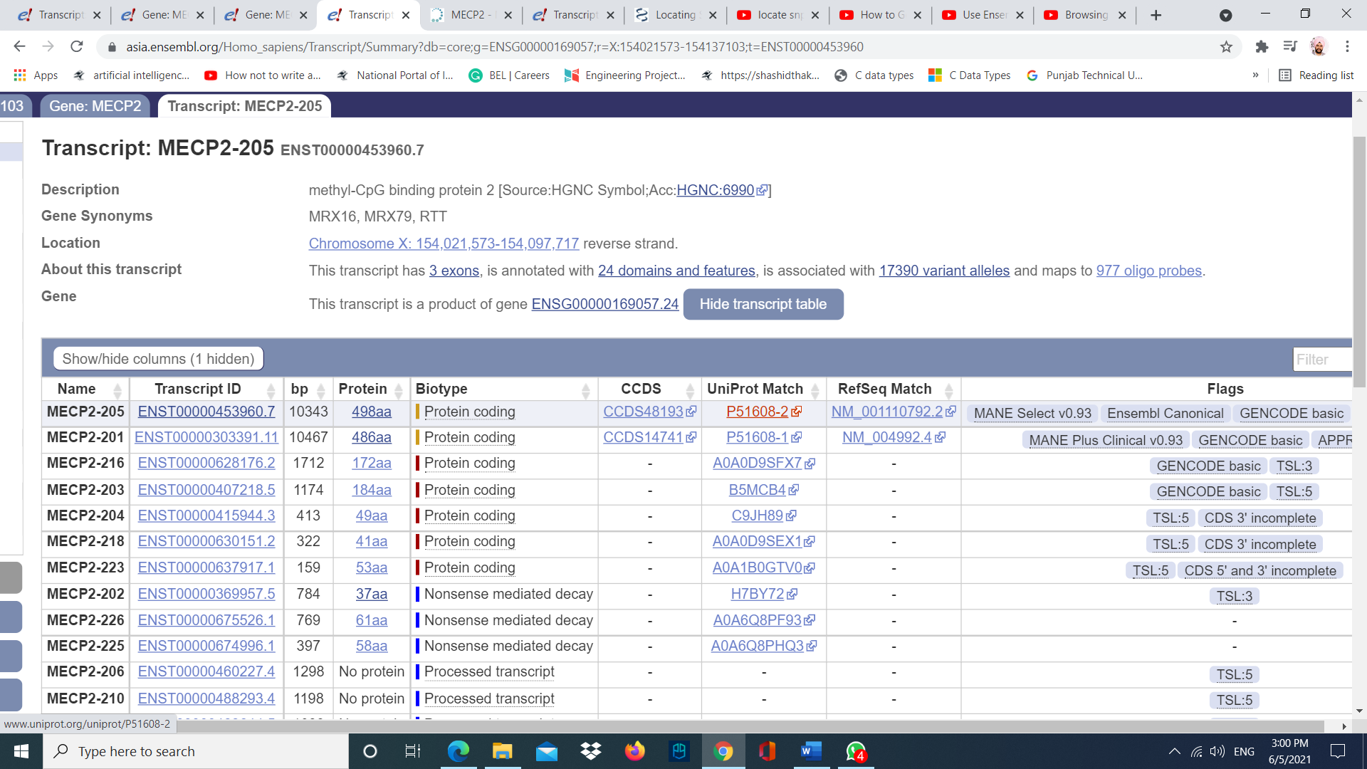

Figure UniProt link in transcript table

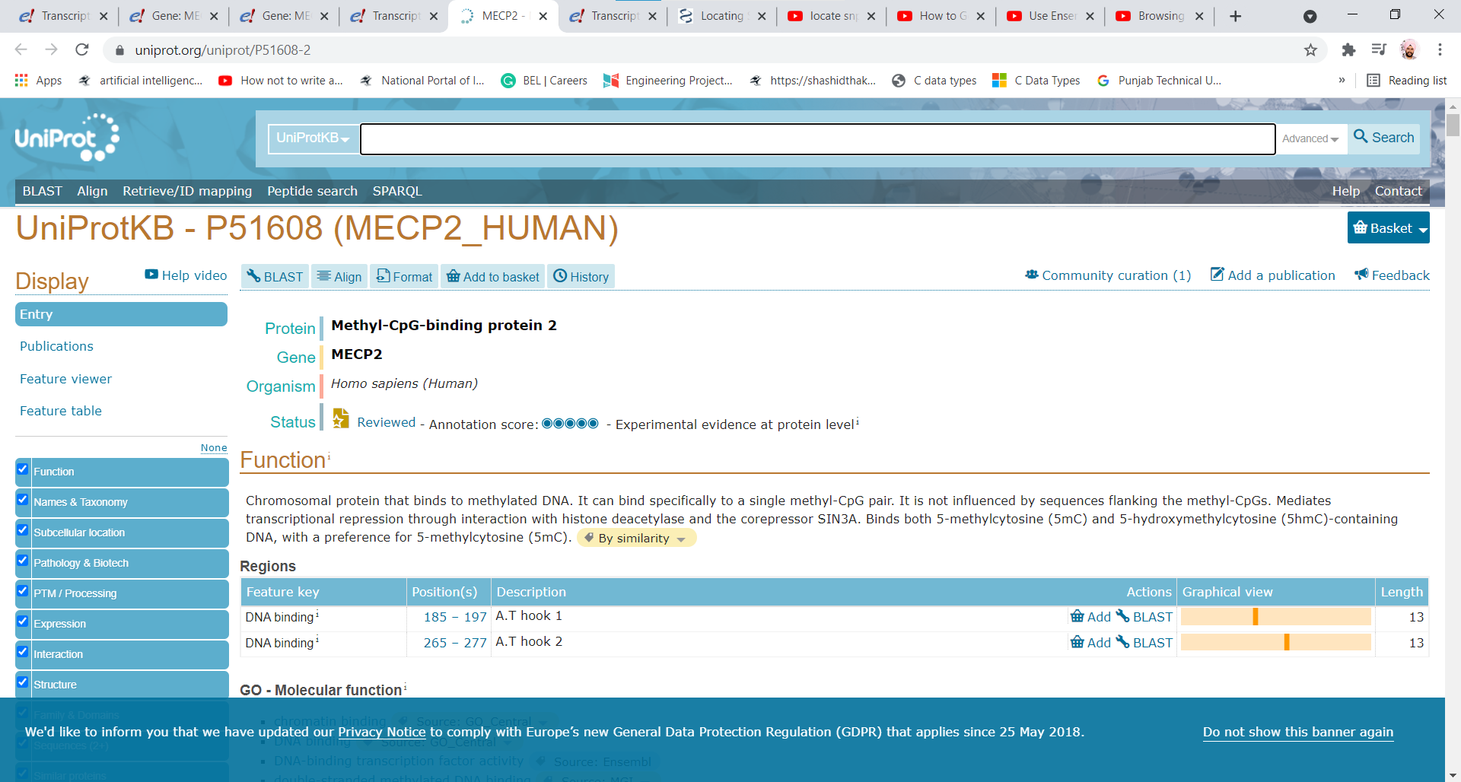

Figure Function of protein MECP2 gene

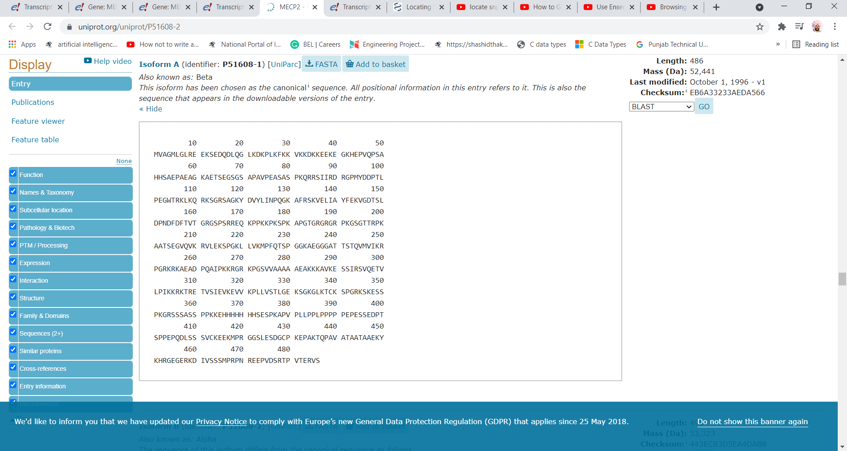

Figure Protein sequence of MECP2 gene

B.

Function of Methyl-CpG-binding protein 2 (MECP2) gene is responsible for building a protein called MeCP2. MeCP2 is present in cells throughout the body and is abundant in brain cells. It is important for functioning of several types of cells including neurons. It helps in maintaining the connections between neurons (synapses). Scientists believed MeCP2 protein is also involved in processing of messenger RNA (mRNA). It helps in rearrangement and cutting of mRNA molecules in different ways to form other proteins.

C.

I used SWISS MODEL for predicting the secondary structure elements of this protein and used PDB (Protein Data Bank) to verify the secondary structure elements of this protein.

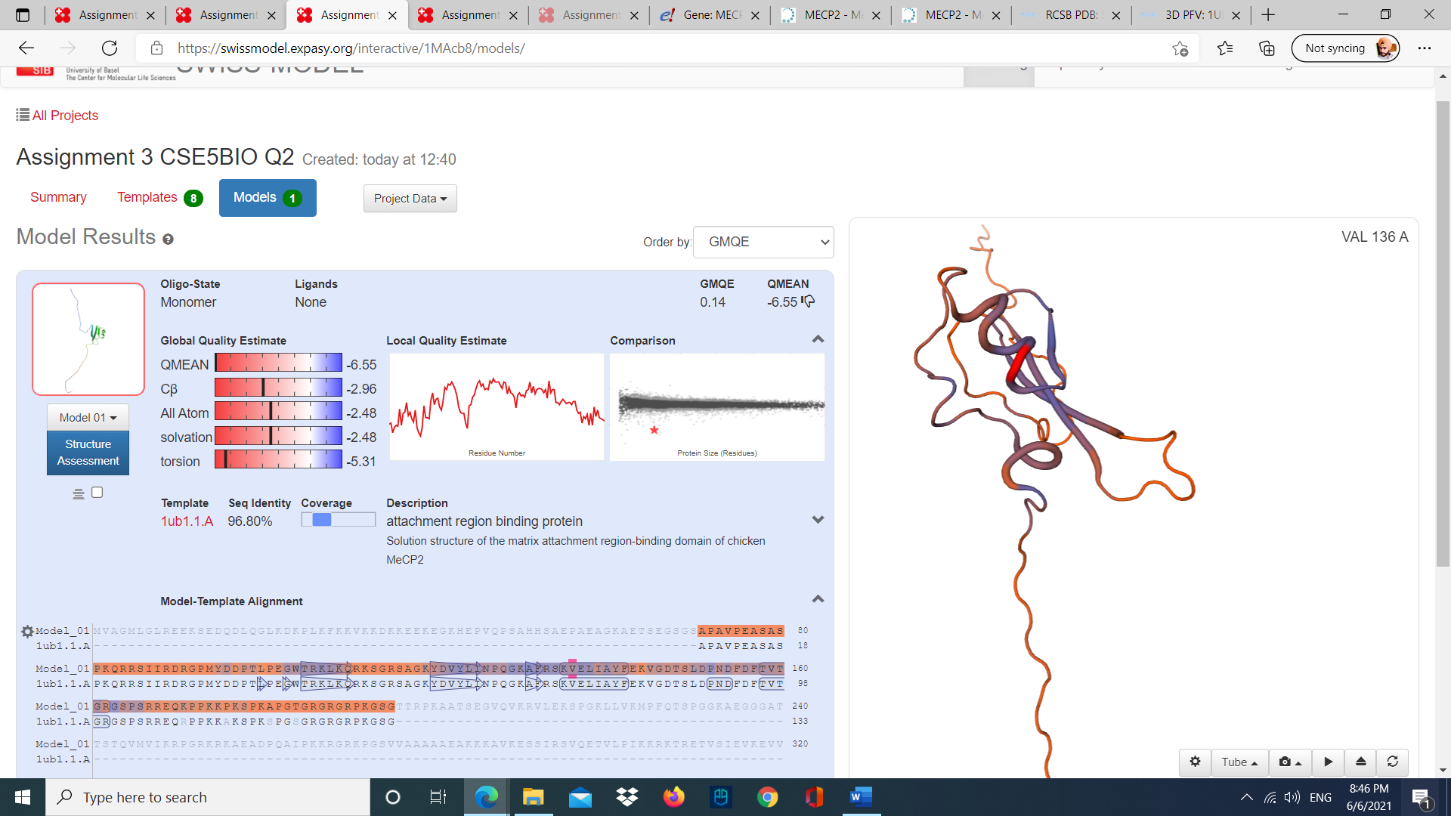

Figure SwissProt model of Human MECP2 protein using 1ub1.1.A template.

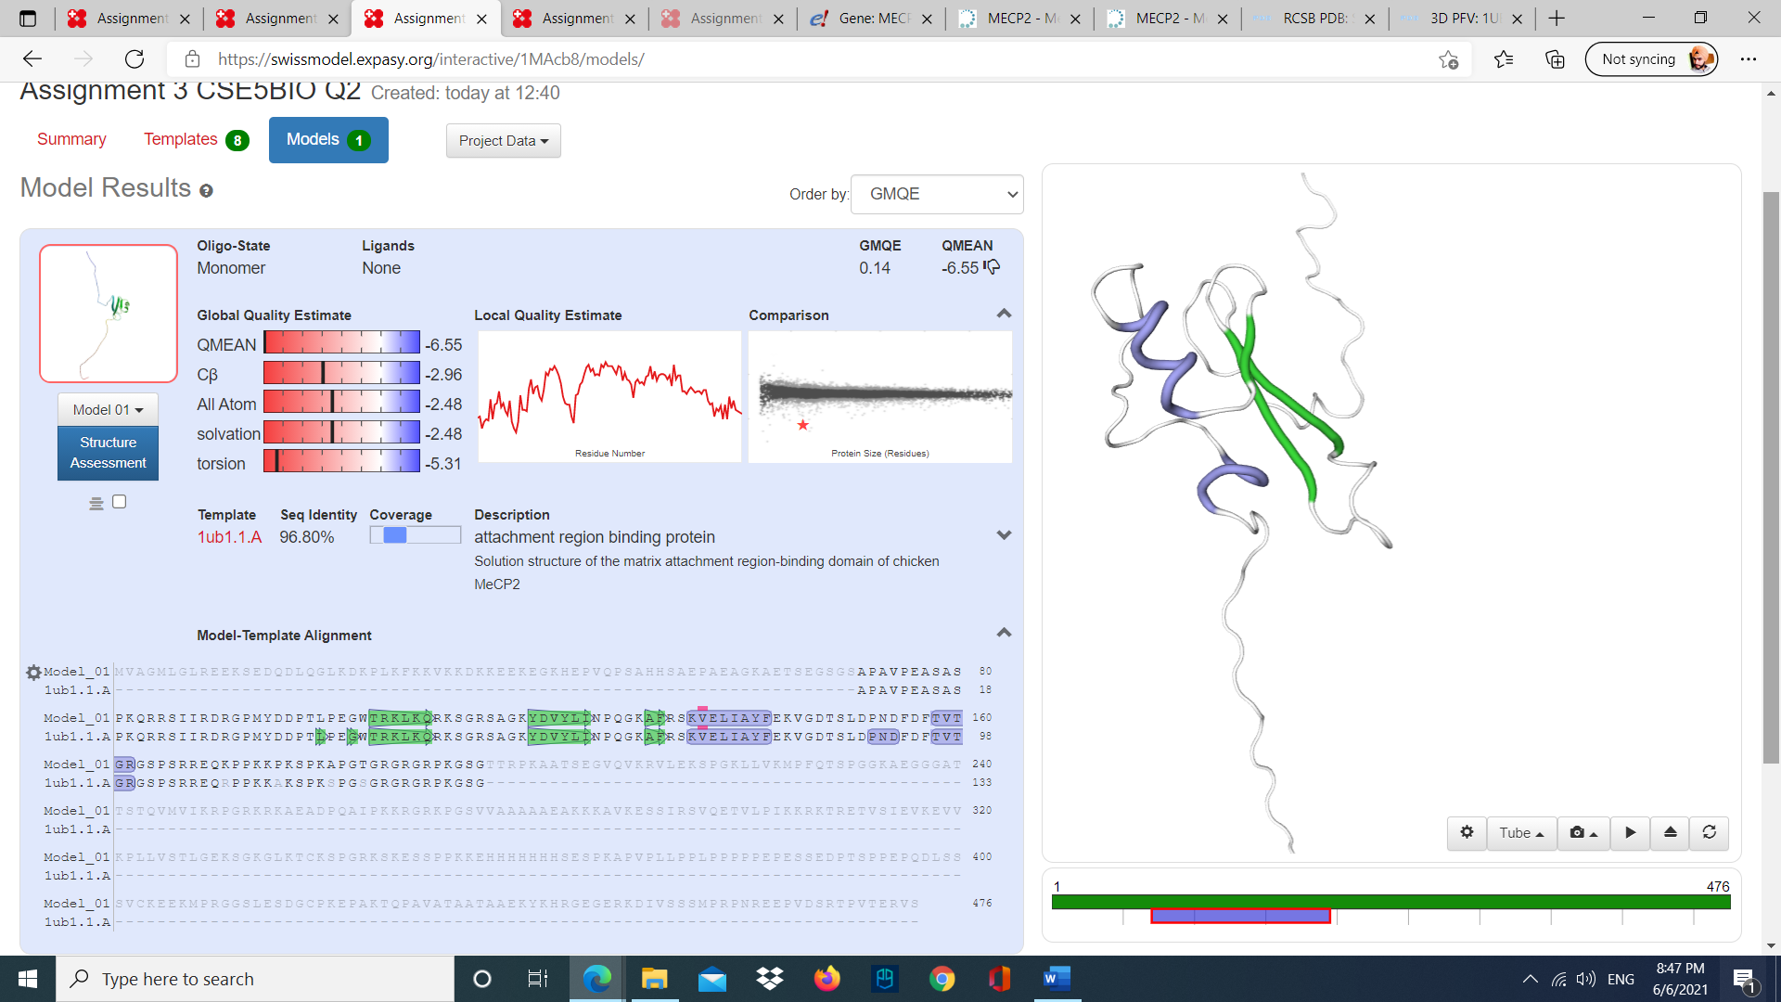

Figure Highlighting the seconday structures

We can see in the figure that green highlighted part of the structure are the three beta sheets, and two blue highlighted parts are alpha helixes. The template name is 1ub1.1.A. The predicted protein structure has 96.8 % sequence identity, 0.26 coverage, 0.14 GMQE and -6.55 QMEAN. GMQE and QMEAN tells the reliability of the predicted model.

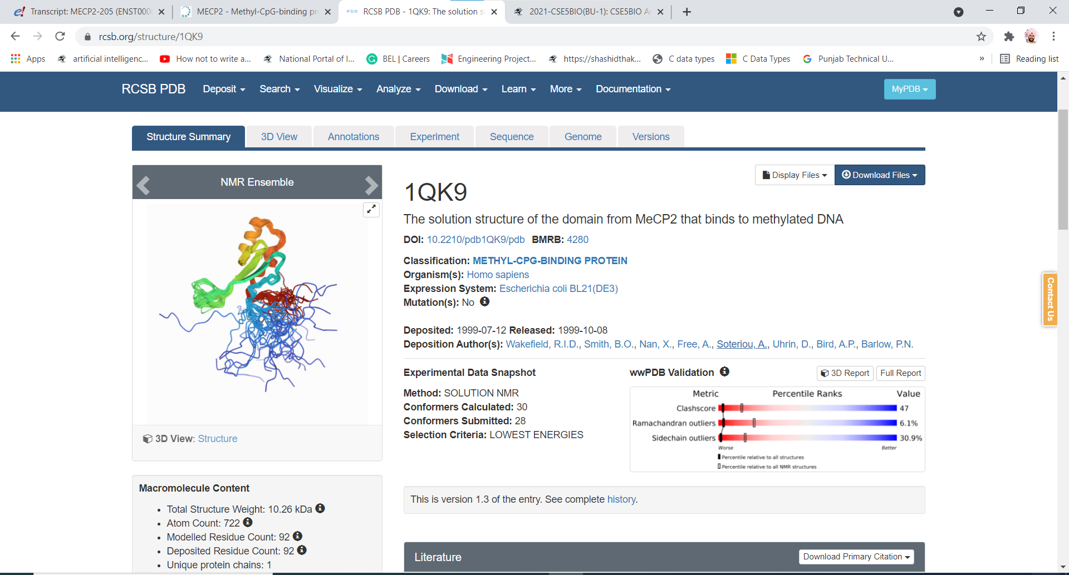

Figure PDB 3D structure of MECP2 protein

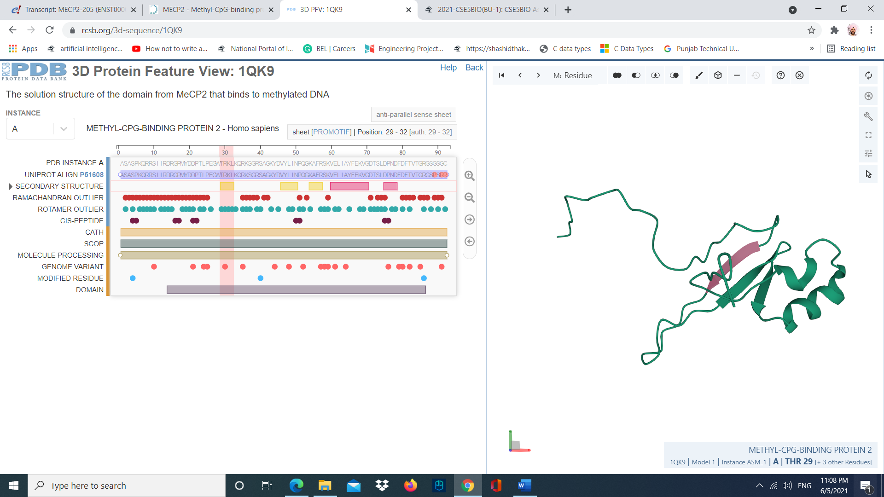

Figure First beta sheet

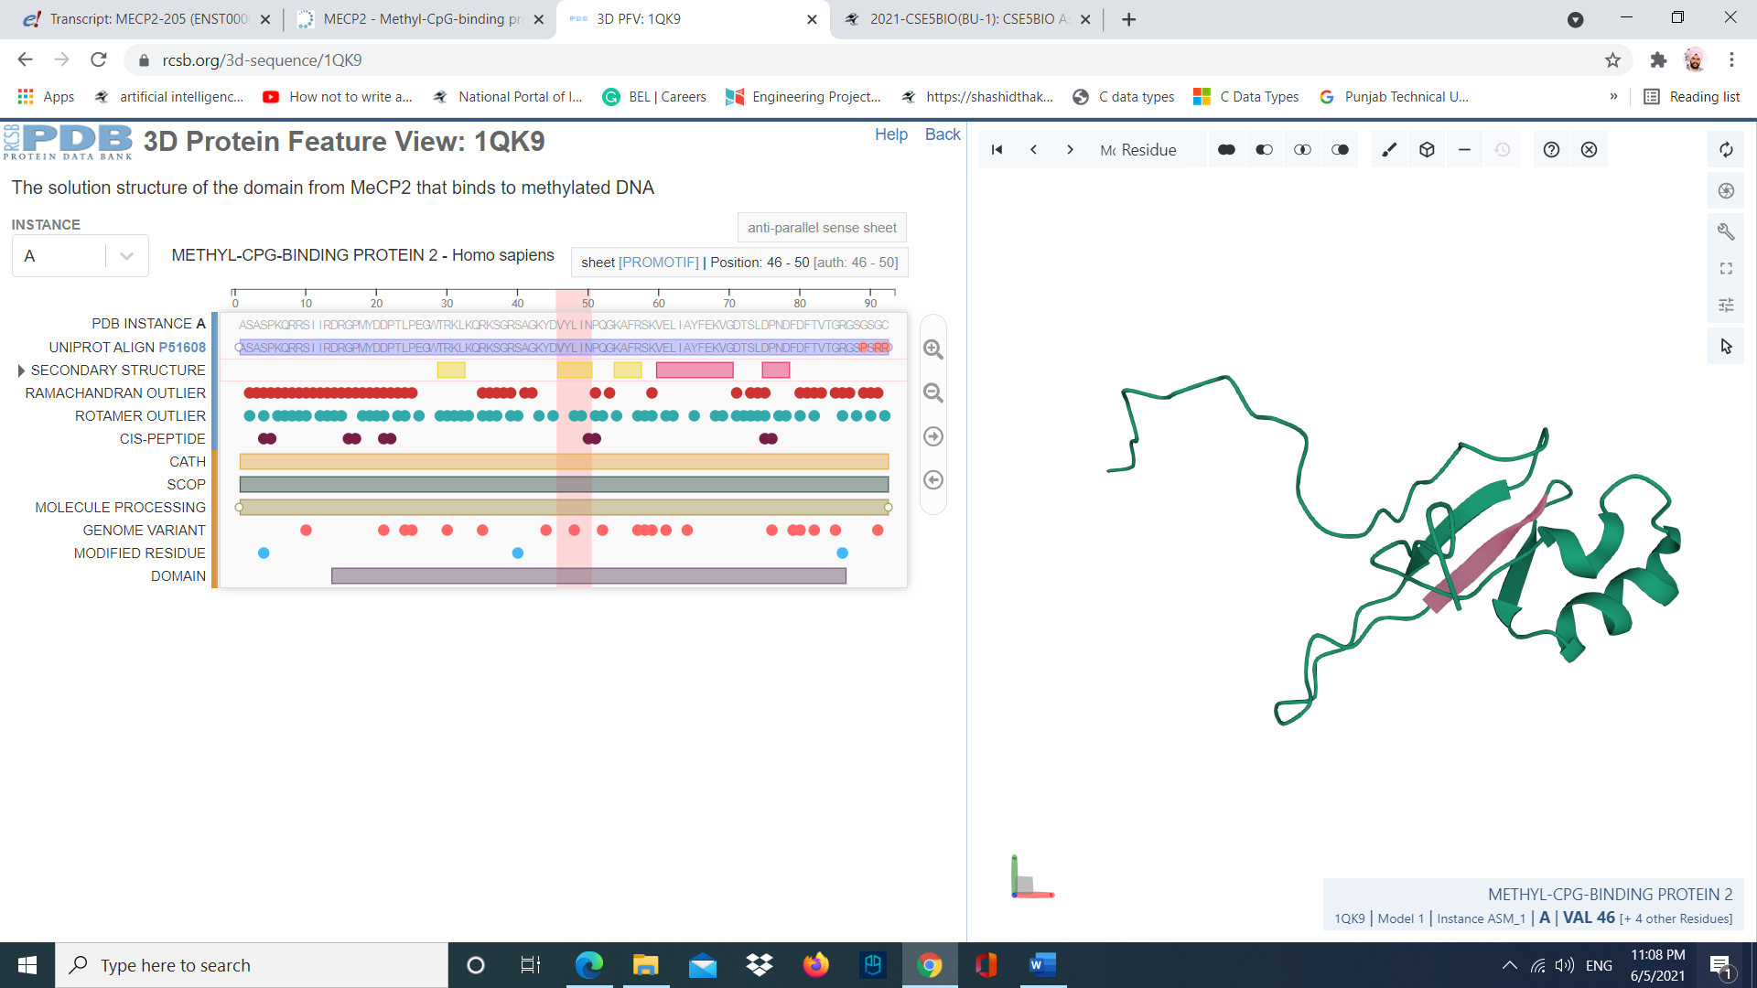

Figure Second beta sheet

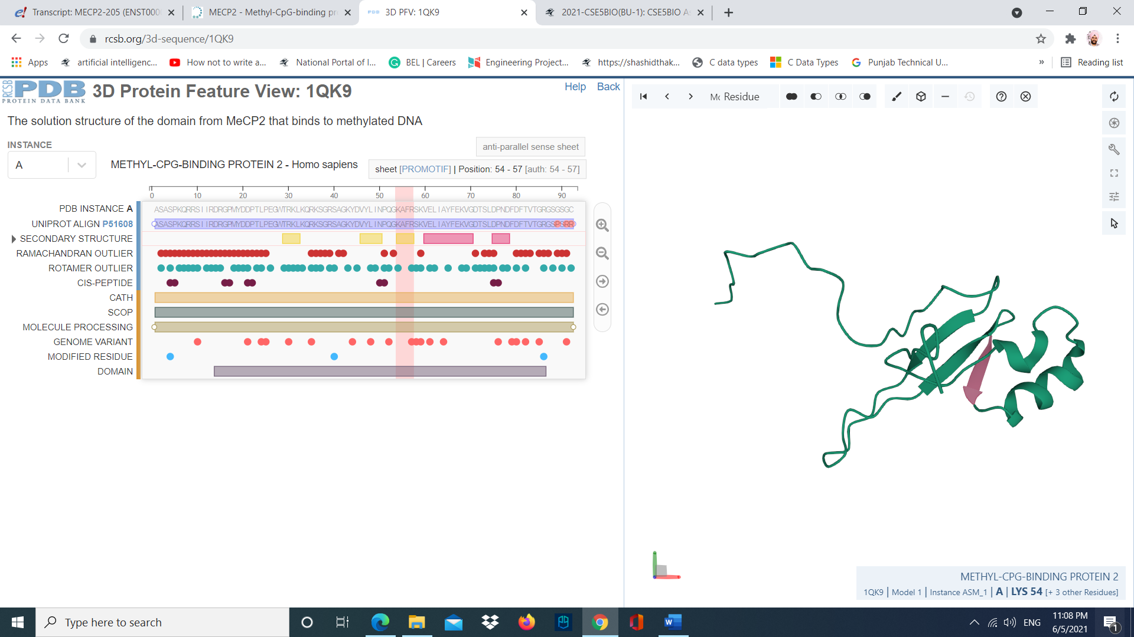

Figure Third beta sheet

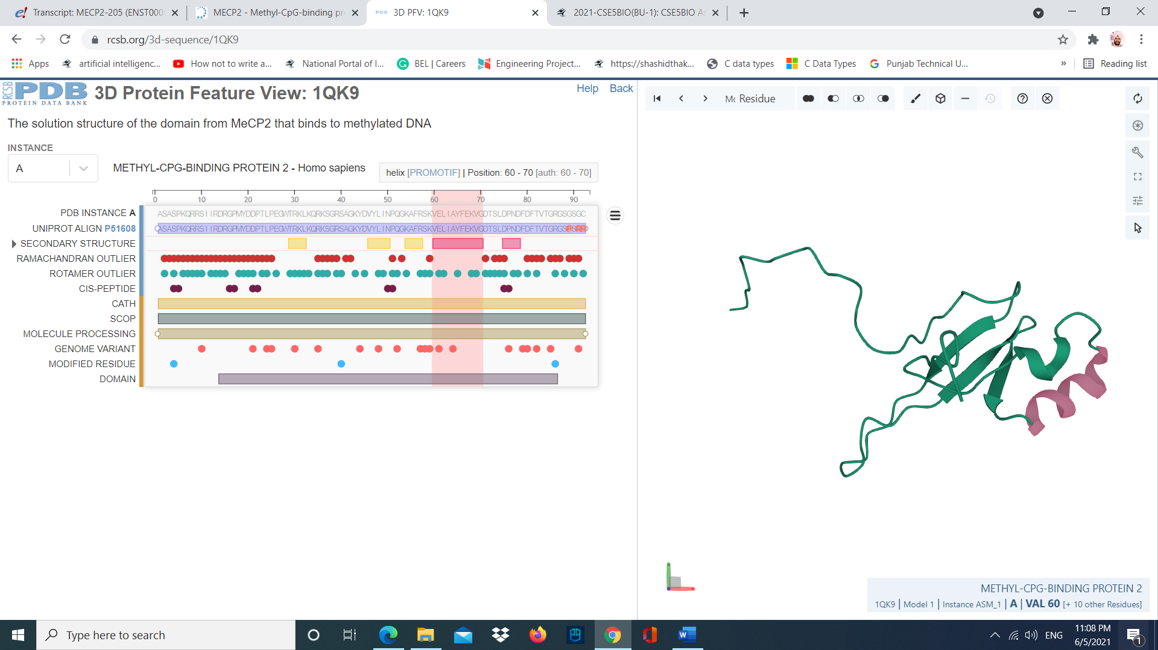

Figure First alpha helix

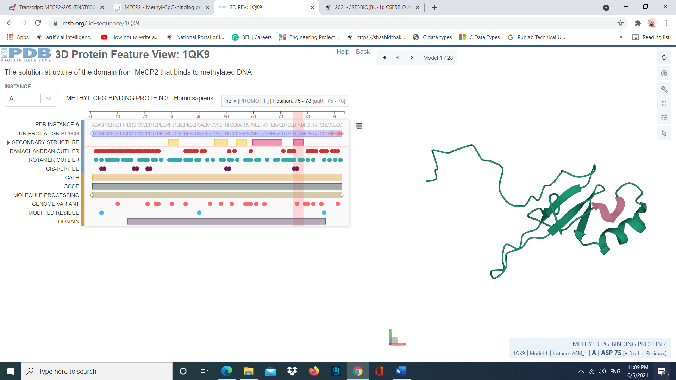

Figure Second alpha helix

The secondary structure section in the diagram shows that there are 3 beta sheets, and 2 alpha helixes present in the protein. This is evident in the 3D protein structure. We can notice that the PDB instance of the protein and the UNIPROT ALIGN P51608 has some mis alignment in the end of the sequence. Also, the domain of the protein containing the helixes and the beta sheets is from 14-86 amino acid in the protein sequence.

Question 3:

|  |
| --- |
| Protein sequence of homo sapiens MECP2:  MVAGMLGLREEKSEDQDLQGLKDKPLKFKKVKKDKKEEKEGKHEPVQPSAHHSAEPAEAGKAETSEGSGSAPAVPEASASPKQRRSIIRDRGPMYDDPTLPEGWTRKLKQRKSGR |
| SAGKYDVYLINPQGKAFRSKVELIAYFEKVGDTSLDPNDFDFTVTGRGSPSRREQKPPKKPKSPKAPGTGRGRGRPKGSGTTRPKAATSEGVQVKRVLEKSPGKLLVKMPFQTSP |
| GGKAEGGGATTSTQVMVIKRPGRKRKAEADPQAIPKKRGRKPGSVVAAAAAEAKKKAVKESSIRSVQETVLPIKKRKTRETVSIEVKEVVKPLLVSTLGEKSGKGLKTCKSPGRK |
| SKESSPPKKEHHHHHHHSESPKAPVPLLPPLPPPPPEPESSEDPTSPPEPQDLSSSVCKEEKMPRGGSLESDGCPKEPAKTQPAVATAATAAEKYKHRGEGERKDIVSSSMPRPN |
| REEPVDSRTPVTERVS |

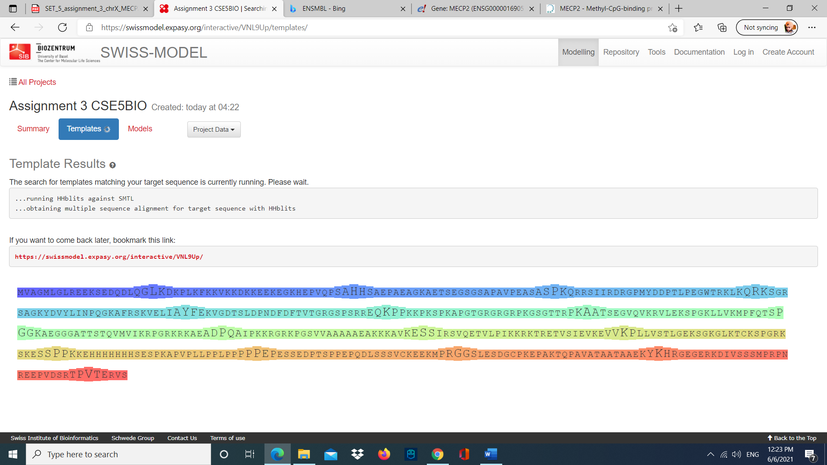

Figure Protein sequence matching

The protein with most coverage (0.26) is [1ub1.1.A](https://swissmodel.expasy.org/templates/1ub1.1) (chicken MeCP2).

B. The sequence’s identity of this protein is 96.8.

C. 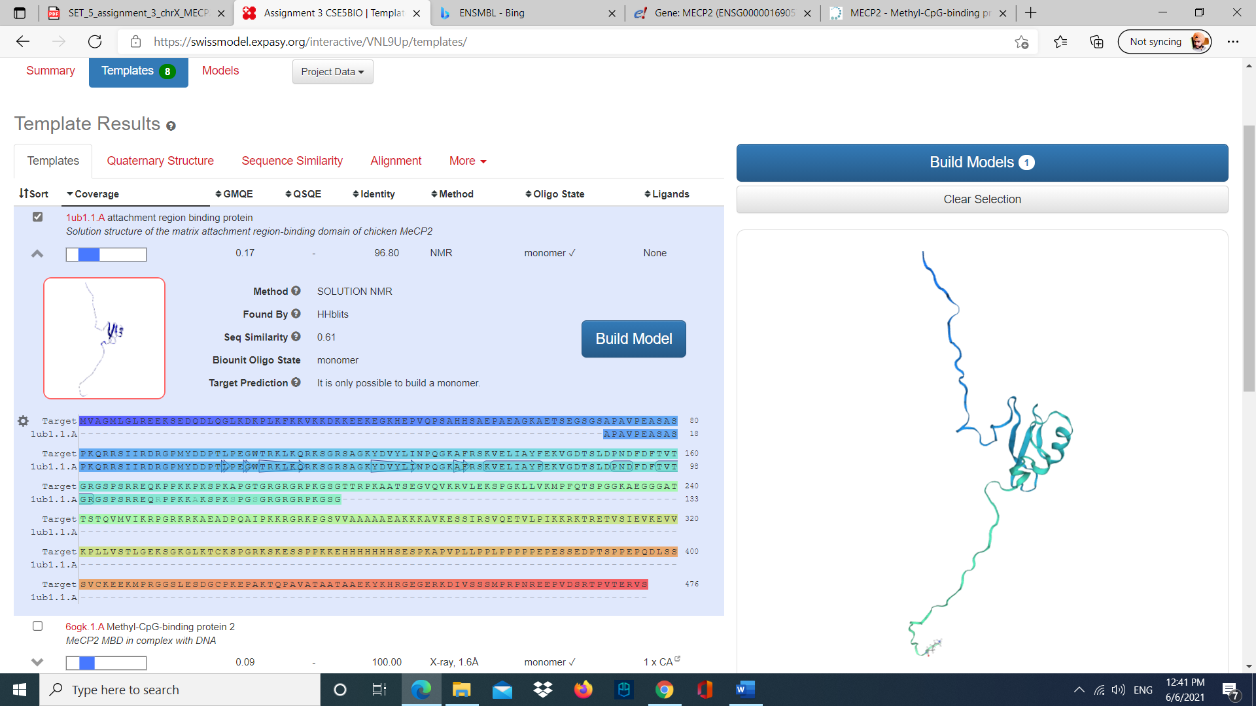

Figure Template of MECP2

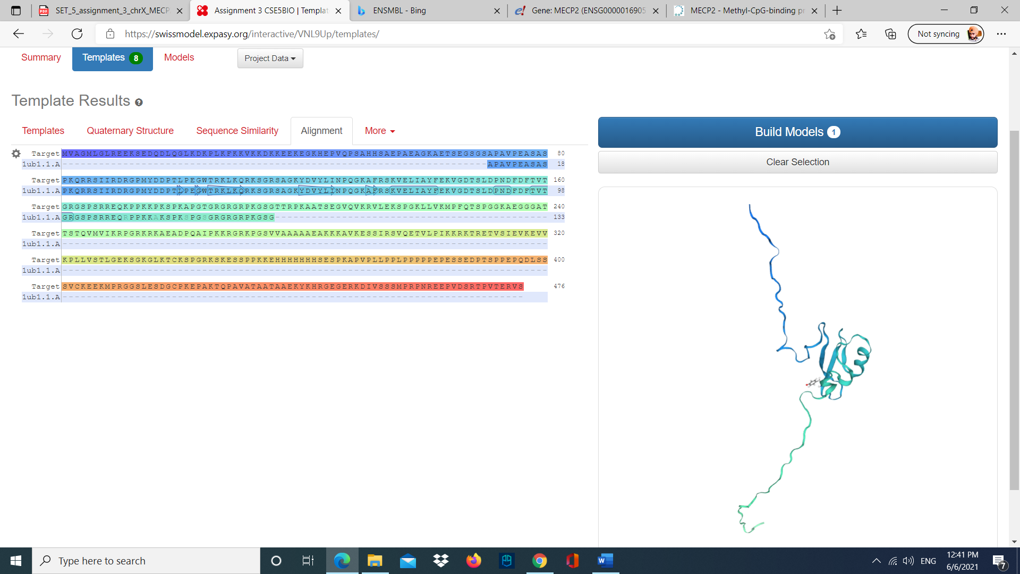

Figure Alignment of MECP2

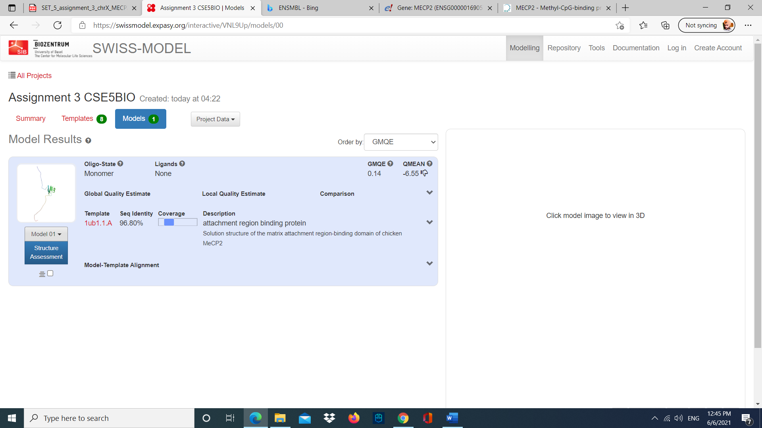

Figure Model results

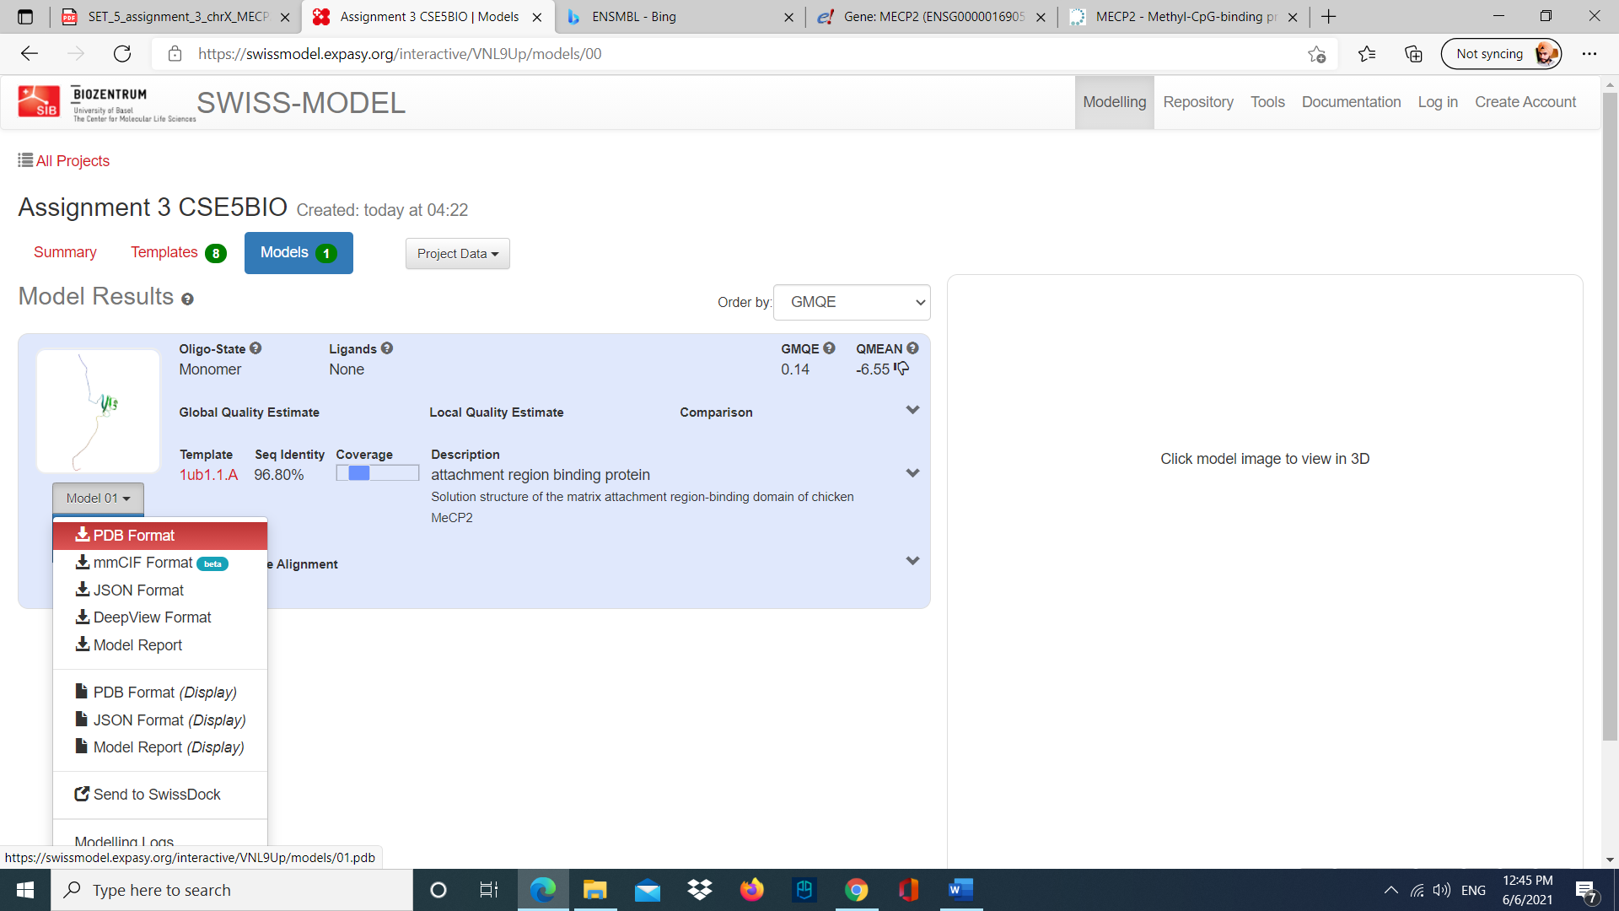

Figure Generating the PDB file

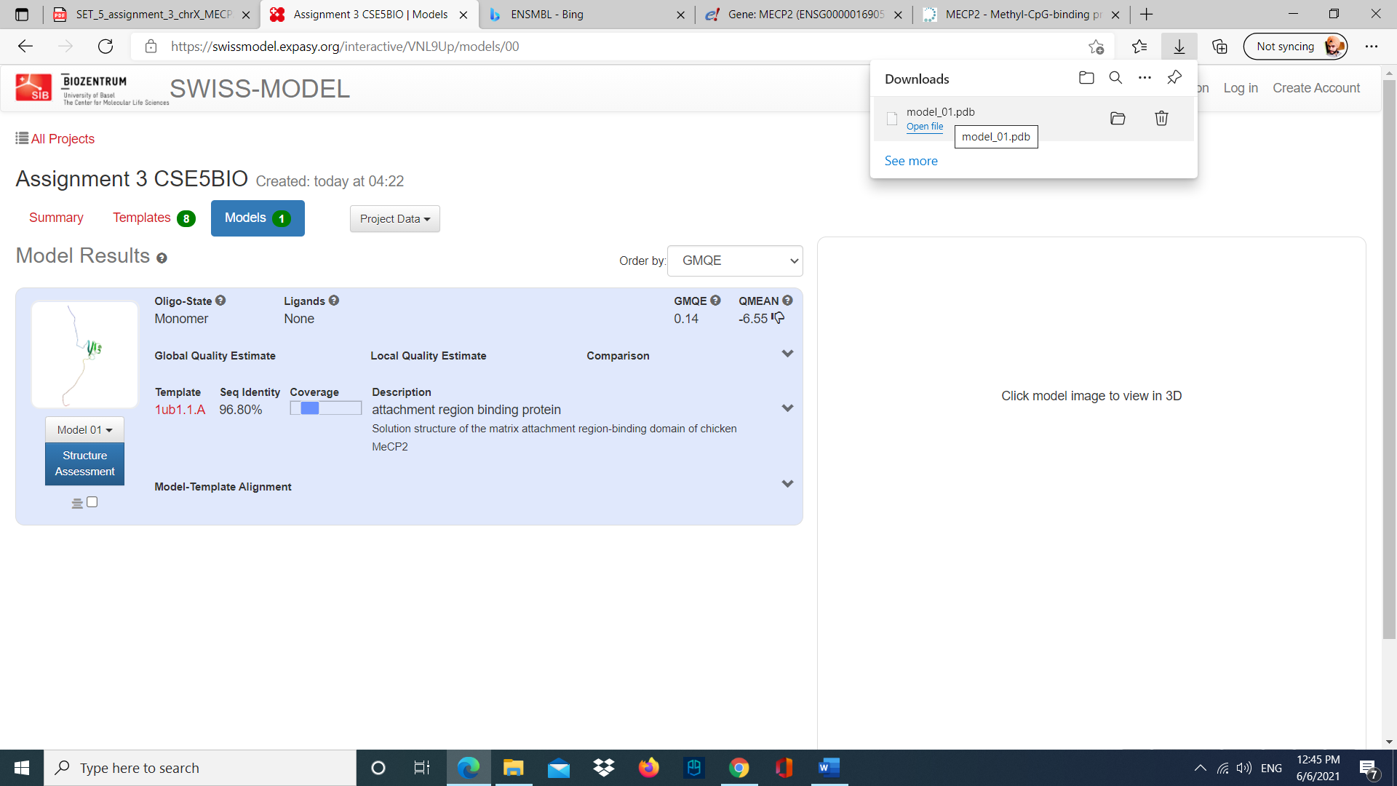

Figure PDB file generated

D.

i. There are 2 helixes, and 3 beta sheets and 14 turns are in the structure.

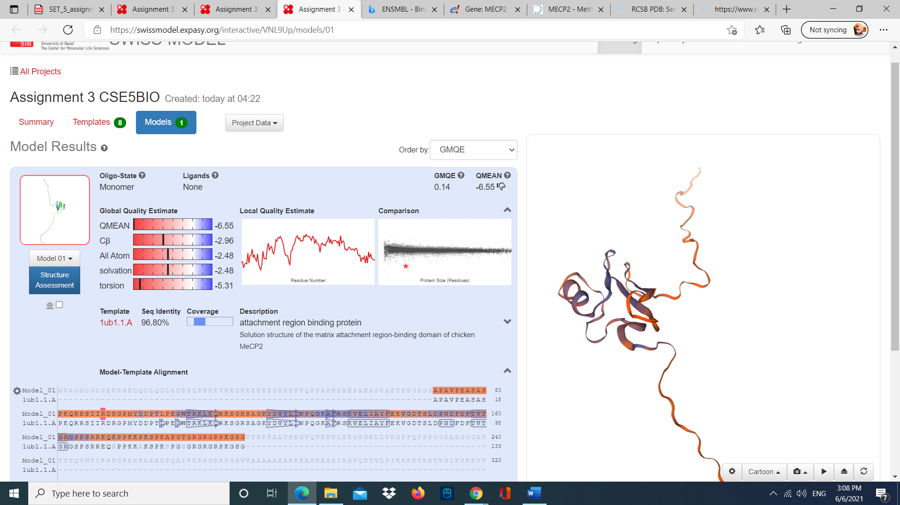

Figure Predicted structure of MECP2.

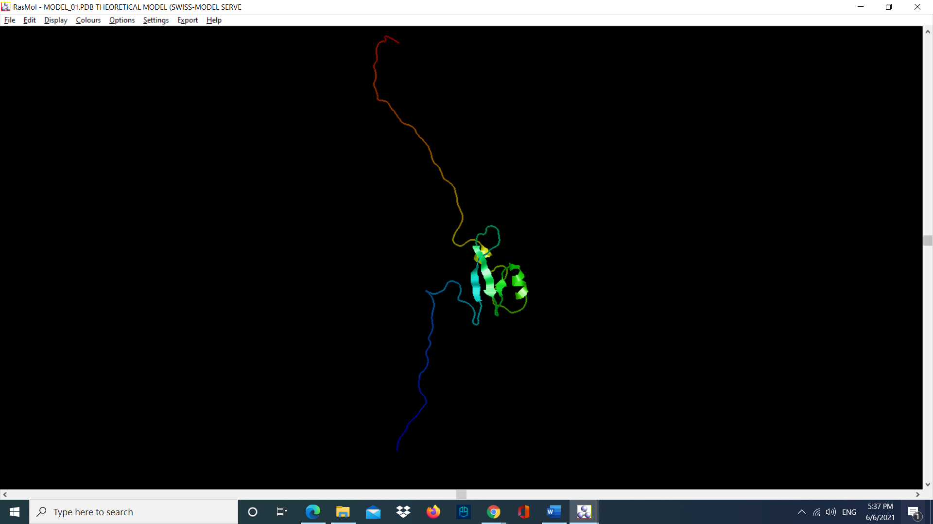

Figure Structure built in RasMOL

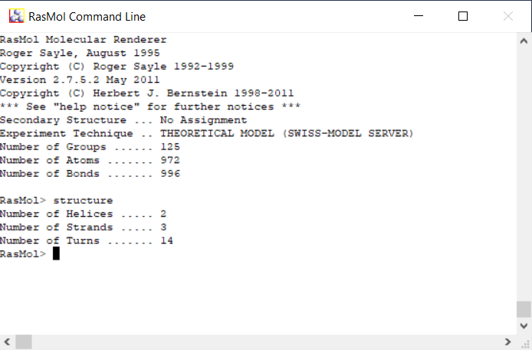

Figure RasMOL command line interface

The number of helixes and beta sheets can help us to learn about the functions of a protein. Also, the helixes and beta sheets are essential for protein-protein interactions, and peptide and protein aggregation. So, this can help researchers find treatment for diseases in which they are involved.

ii.

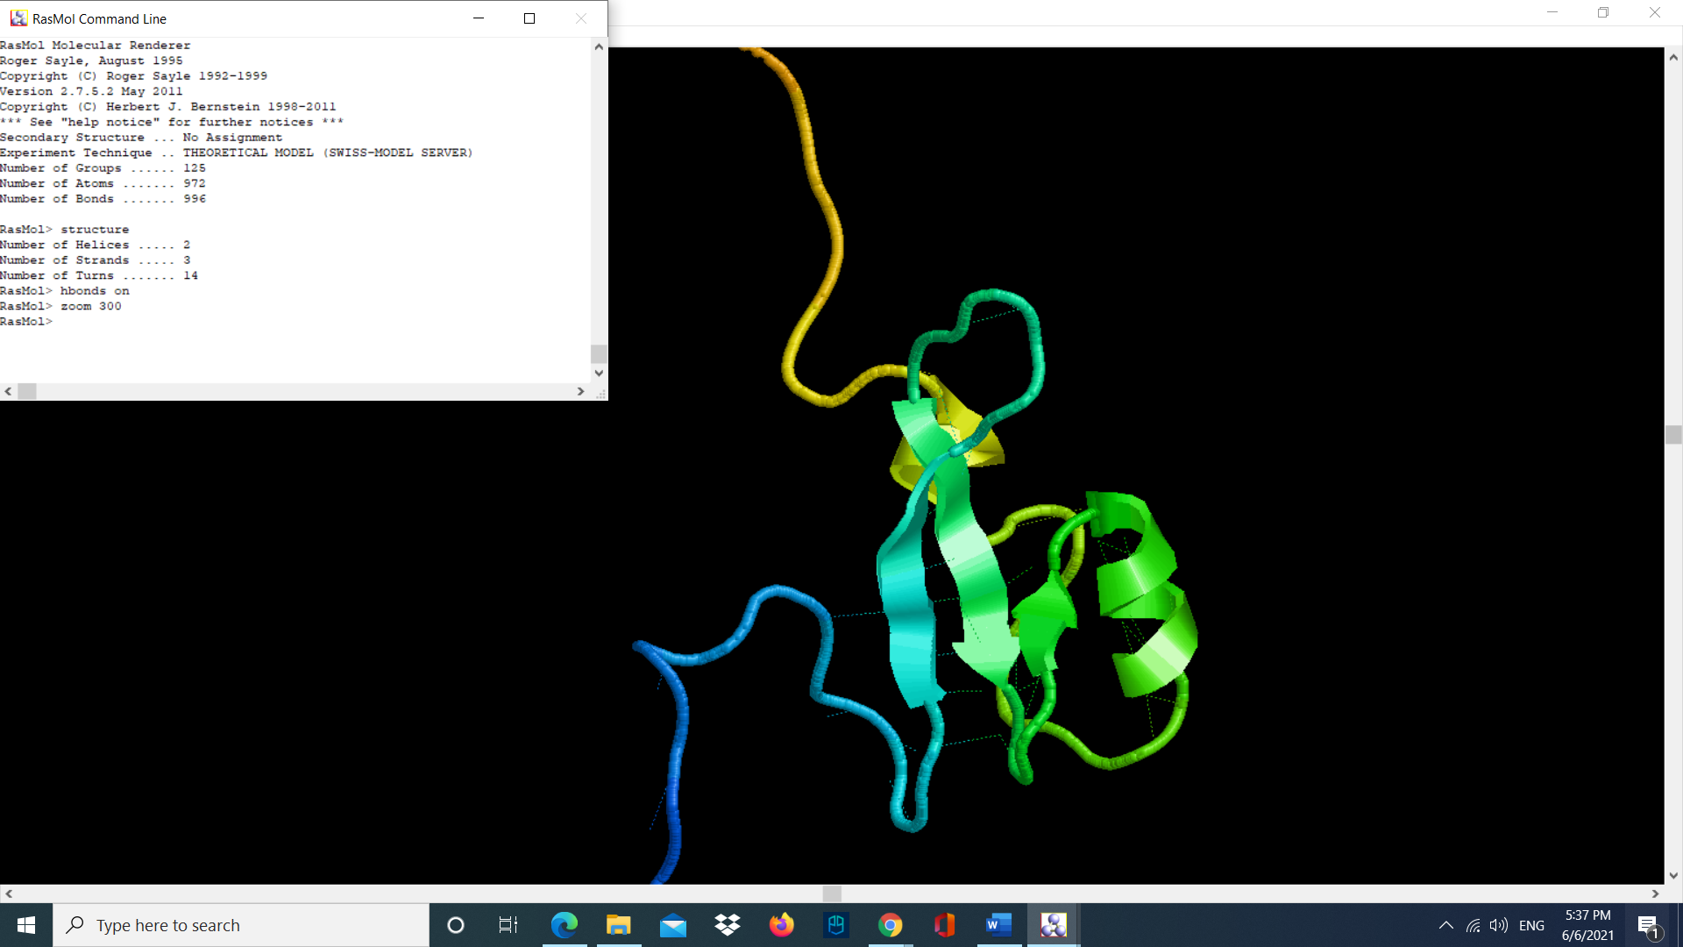

Figure Highlighting the Hydrogen Bonds

Hydrogen bonds are important for stabilizing the structure of protein which is formed by alpha helixes, beta sheets, turn and loops. The H-bonds connects the amino acids in protein structures. Number of hydrogen bonds tell us about the protein stability.

E. The GMQE and the QMEAN score tells that the model is not reliable as the GMQE score is 0.14 which is very low and the QMEAN score is -6.55 which is below -4.0 (which indicates model with low quality).

Question 4:

A.

The protein sequence with highest similarity is MCPE2 of Hylobates Moloch.

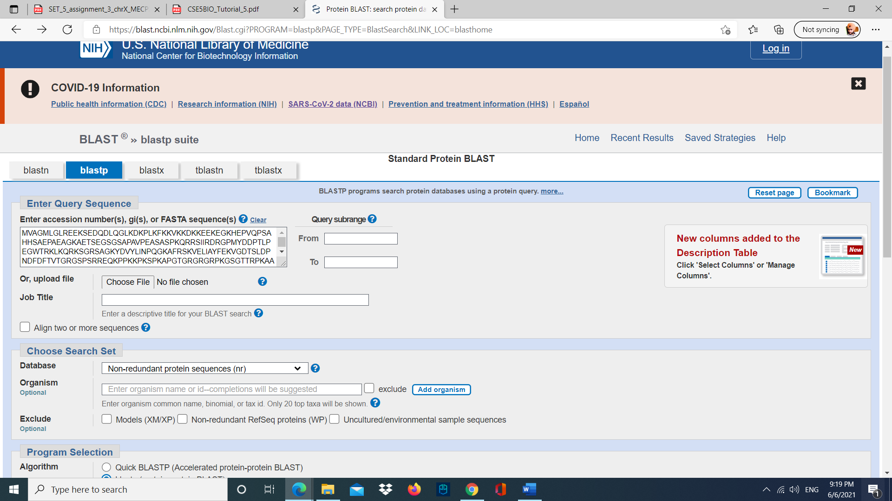

Figure Blasting the sequence in Protein Blast (NCBI)

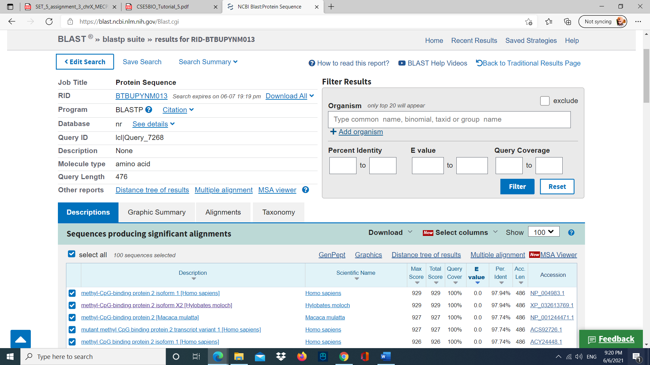

Figure Result page of blasting

B.

I used Protein Blast to find the similar sequences.

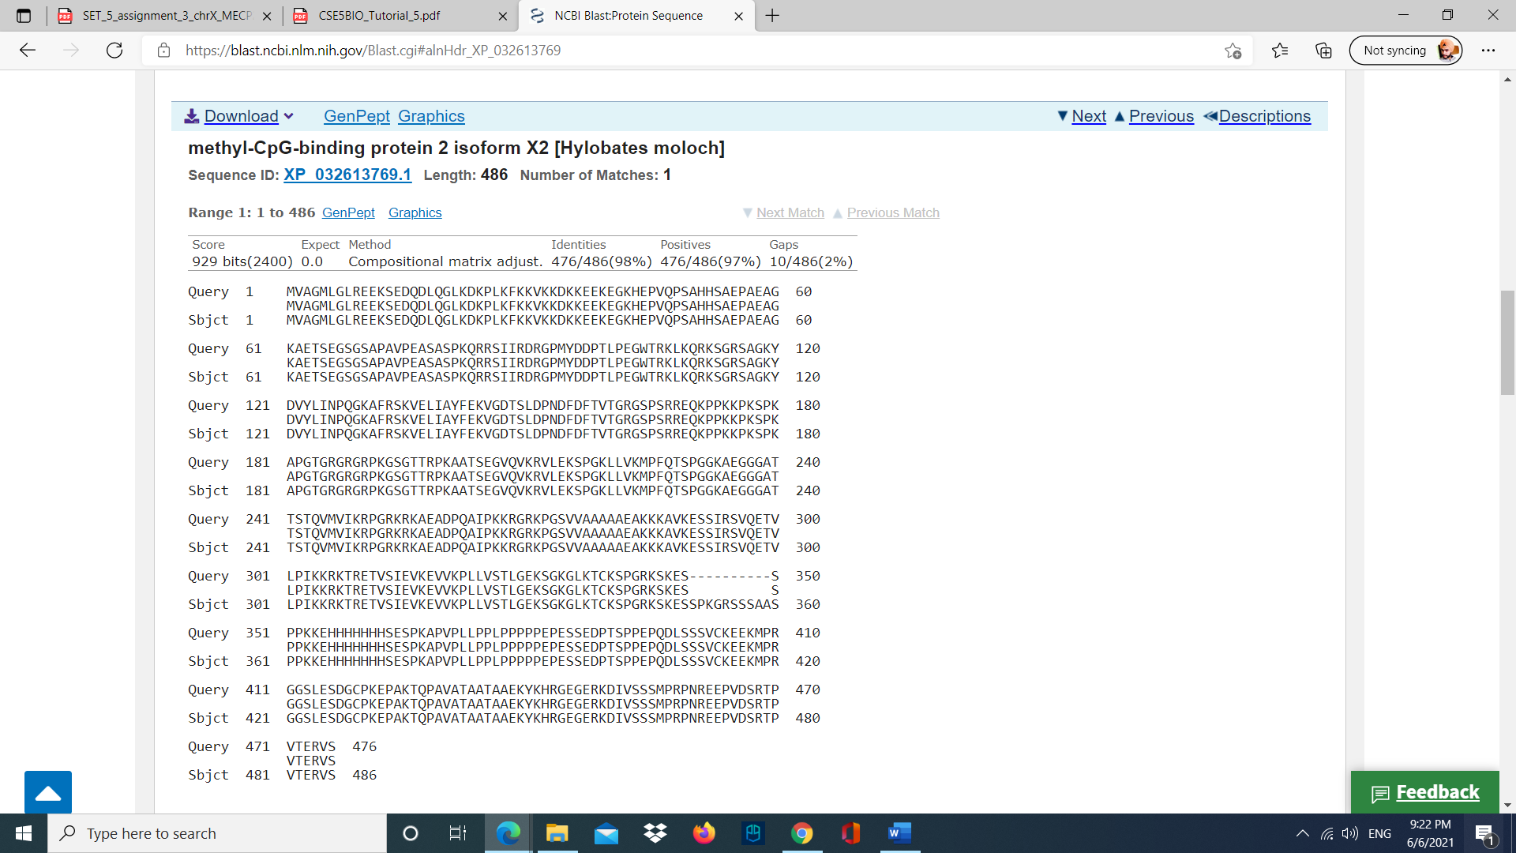

Figure Sequence alignment of Hylobates moloch MECP2 with Homo sapiens MECP2.

C.

The downloaded protein sequence:

>XP_032613769.1 methyl-CpG-binding protein 2 isoform X2 [Hylobates moloch]

MVAGMLGLREEKSEDQDLQGLKDKPLKFKKVKKDKKEEKEGKHEPVQPSAHHSAEPAEAGKAETSEGSGSAPAVPEASAS

PKQRRSIIRDRGPMYDDPTLPEGWTRKLKQRKSGRSAGKYDVYLINPQGKAFRSKVELIAYFEKVGDTSLDPNDFDFTVT

GRGSPSRREQKPPKKPKSPKAPGTGRGRGRPKGSGTTRPKAATSEGVQVKRVLEKSPGKLLVKMPFQTSPGGKAEGGGAT

TSTQVMVIKRPGRKRKAEADPQAIPKKRGRKPGSVVAAAAAEAKKKAVKESSIRSVQETVLPIKKRKTRETVSIEVKEVV

KPLLVSTLGEKSGKGLKTCKSPGRKSKESSPKGRSSSAASPPKKEHHHHHHHSESPKAPVPLLPPLPPPPPEPESSEDPT

SPPEPQDLSSSVCKEEKMPRGGSLESDGCPKEPAKTQPAVATAATAAEKYKHRGEGERKDIVSSSMPRPNREEPVDSRTP

VTERVS

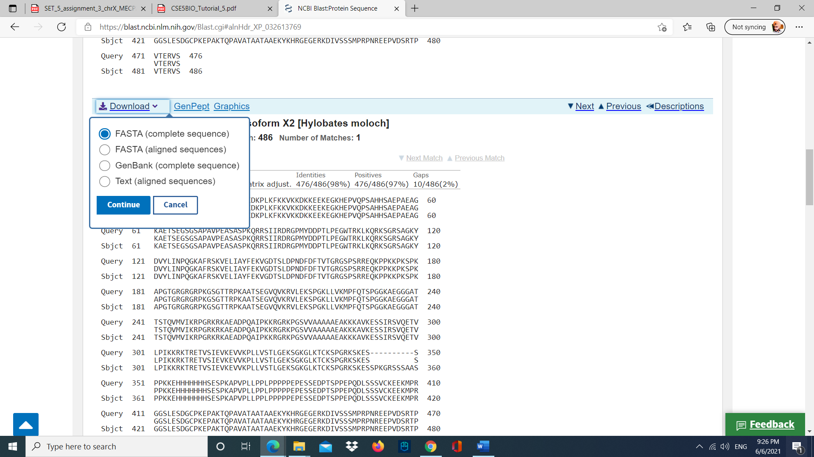

Figure downloading the fasta sequence

The sequence is from silvery gibbon (primate) and is identical to the Human protein except a few amino acids are missing in human protein due to evolution (position 349-359) as illustrated in the figure.

D.

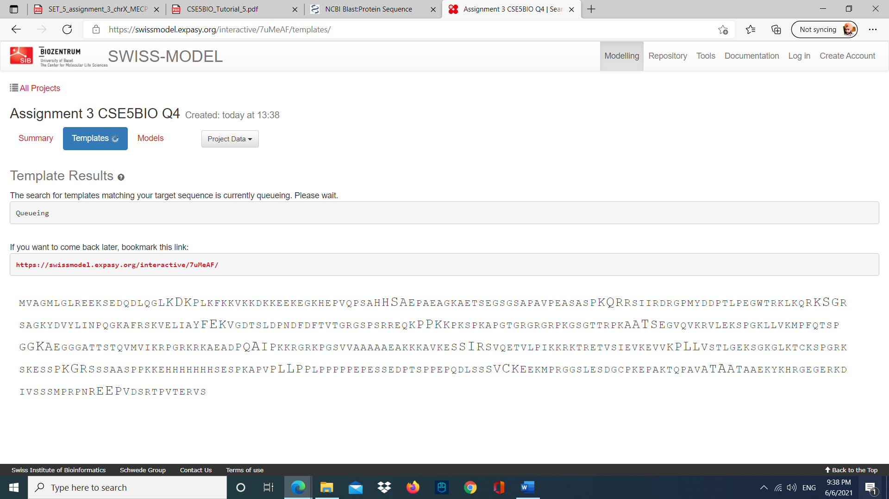

Figure Swiss-MODEL creating a template of the sequence of Hylobates moloch MECP2.

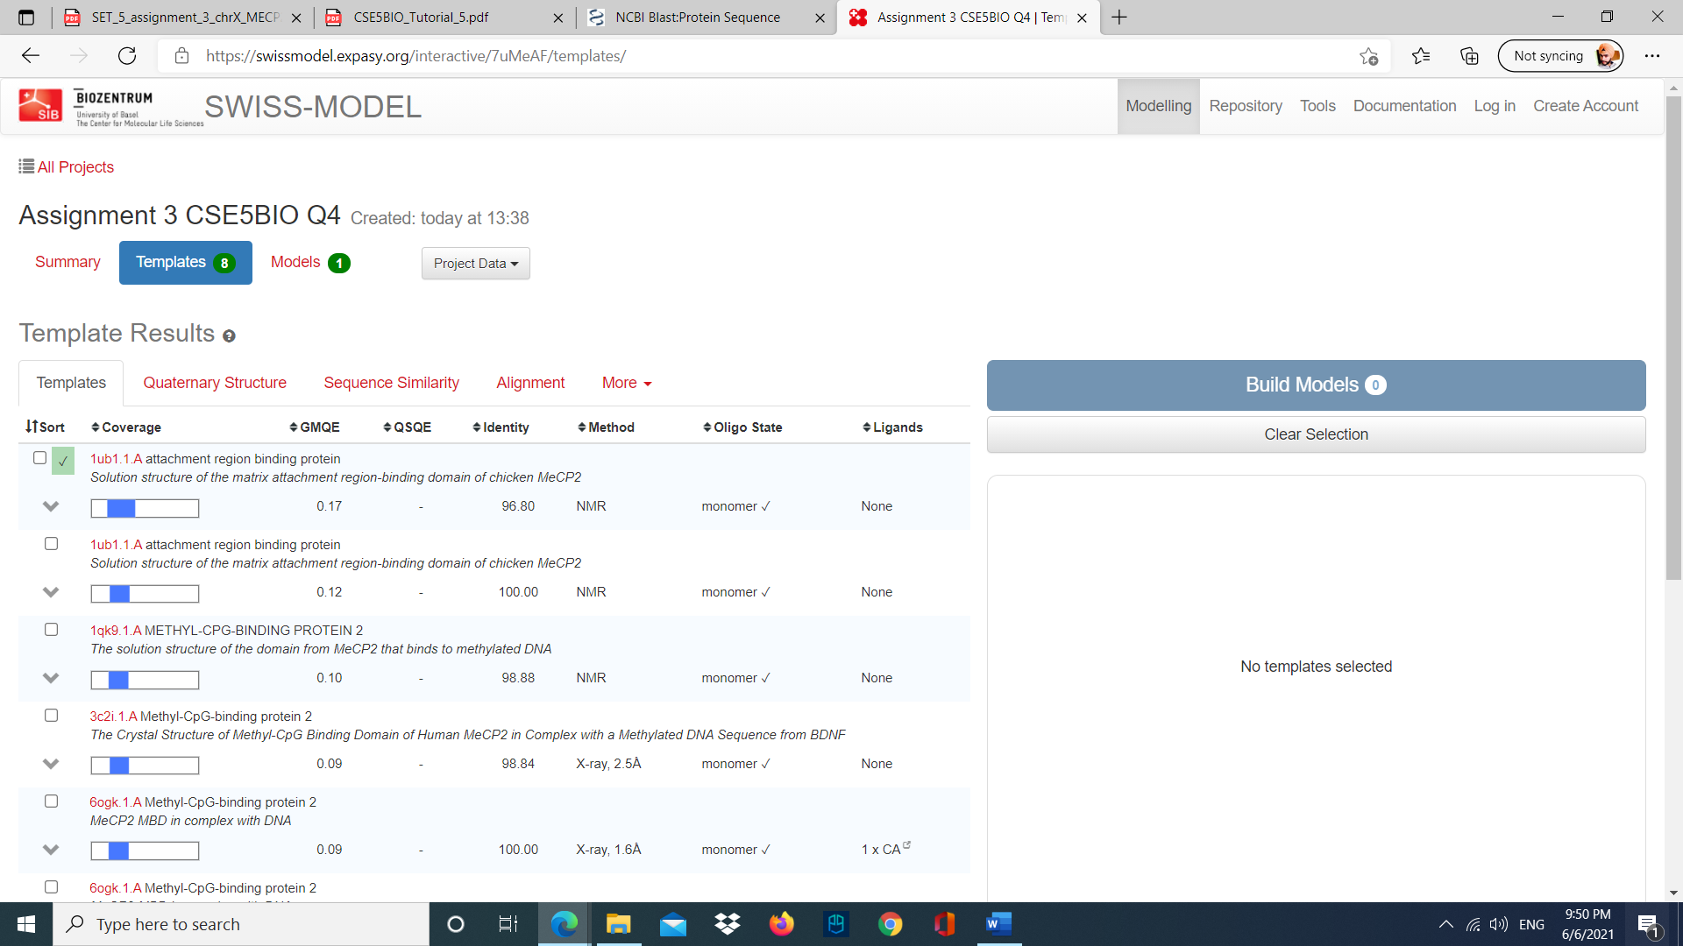

Figure Hylobates moloch MECP2 templates.

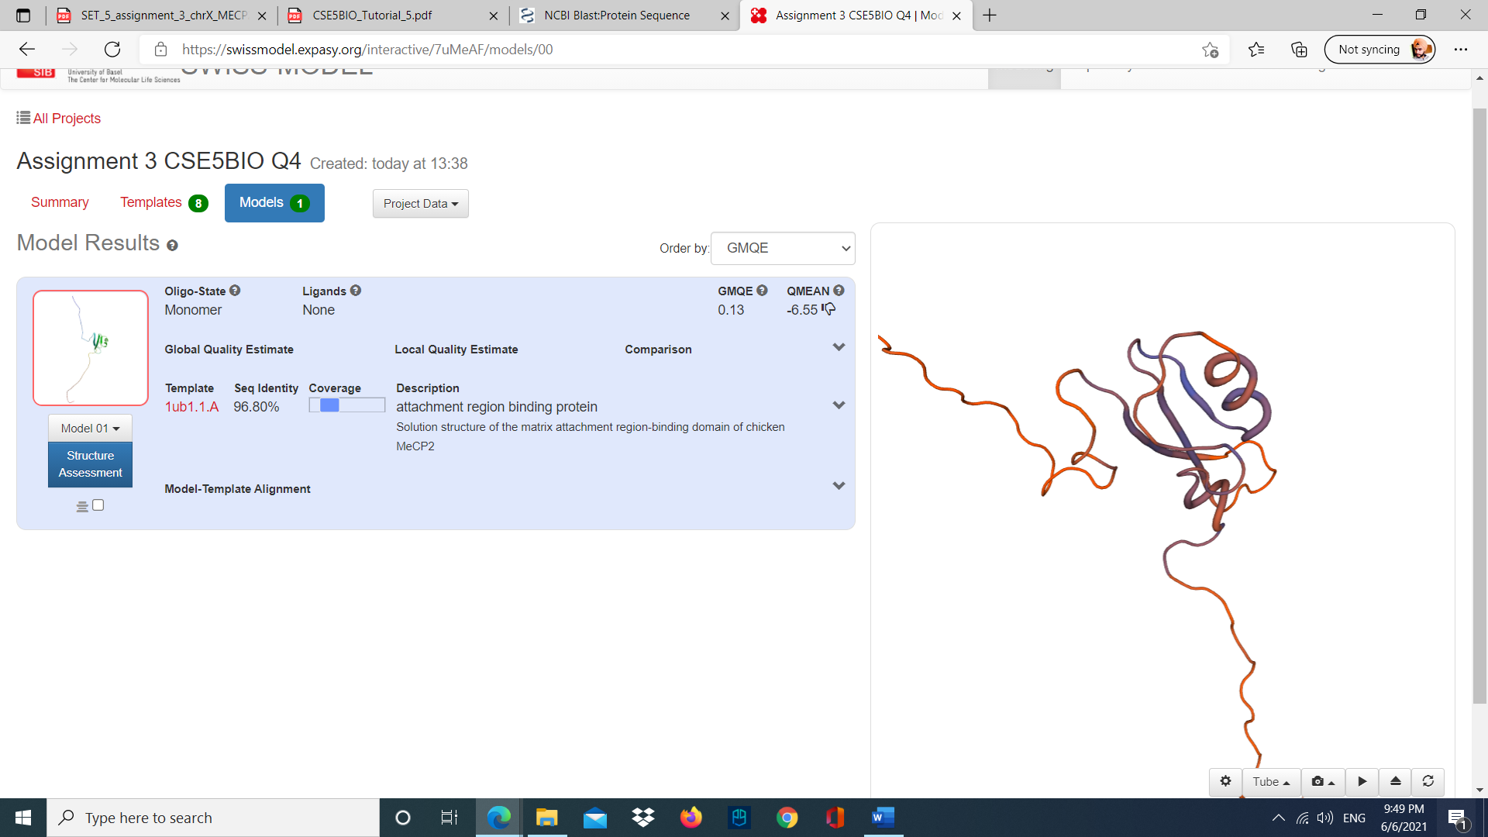

Figure Hylobates moloch MECP2 predicted structure.

E.

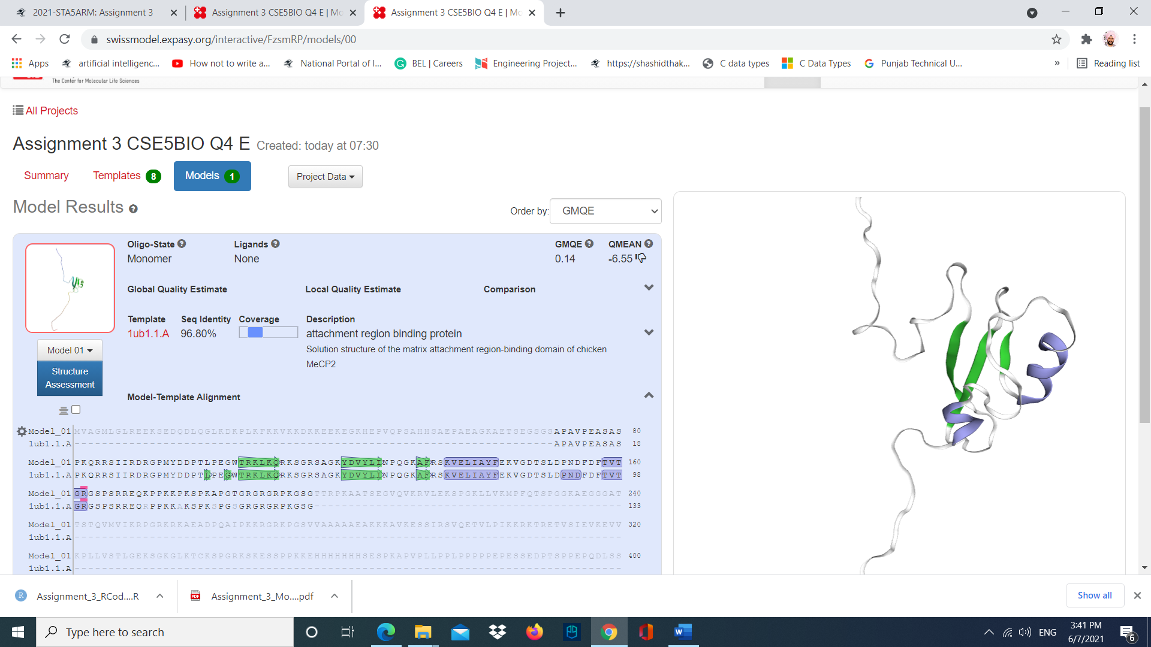

Figure 40 SWISS MODEL protein structure of MCPE2 of Homo sapiens the using [1ub1.1.A](https://swissmodel.expasy.org/templates/1ub1.1) (chicken MeCP2) template.

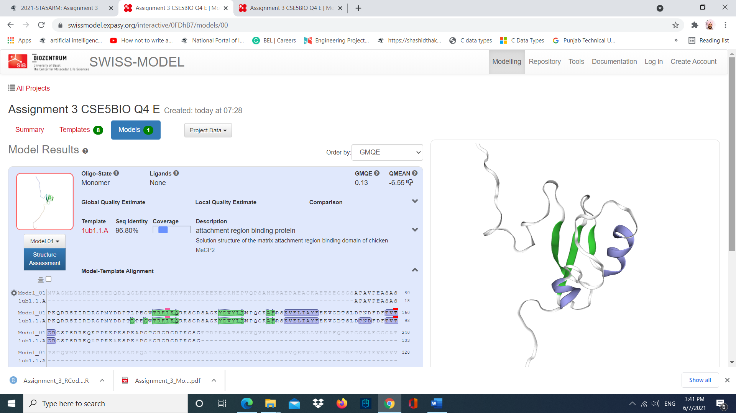

Figure 41 SWISS MODEL protein structure of MCPE2 of Hylobates Moloch (silvery gibbon) using [1ub1.1.A](https://swissmodel.expasy.org/templates/1ub1.1) (chicken MeCP2) template.

Both structures are modelled using the same template. We can see that both structures are approximately the same. Both structures show that they have same number of helixes and beta sheets. Both have same coverage, seq identity, and QMEAN. However, GMQE is different. It means that both proteins have similar properties, and the models have almost similar reliability.

Question 5.

A.

There are many issues in the code which are listed below:

* We cannot use a character and a number together as a variable. In the code we have “8li”. We should use “li” instead.
* We need to give indentation for our code inside a function. Also, for “if” condition we need to indent further.
* In for loop, we are using variable “a” and in “if” condition we are using variable “b”. We need to use the same variable.
* The variable “8li” we should declare it as a global variable (outside the function). But it is declared inside a function. We cannot use it to pass into the function like translate(8li). Also, we should use “li” instead.
* While declaring the function in round brackets we need to add “self”. Like - def translate(self). “self” variable represents the instance of the object itself.
* In “if” condition we can use “replace” to replace the character. Like- a.replace("T", "U").

B.

We can rewrite the given code as

li = "ATGC"

def translate(self):

  for a in li:

    if a == "T":

      print(a.replace("T", "U"))

    else:

      print(a)

translate(li)

This part transcribes a DNA sequence to mRNA. However, the code is still incomplete and incorrect. It gives an output as “AUGCNone” and we get “None” at the end as we are not returning any variable. Also, it does not include translation part where we convert codons into a polypeptide sequence.

So, I rewrite the code as:

li = "ATGC"

li = li.replace("T", "U")

print(li)

li = [li[n:n+3] for n in range(0, len(li), 3)]

print(li)

nucleotide_sequence_lookup_table = {

    'AUG': "M",

    'UUU': "F",

    'UUC': "F",

    'UUA': "L",

    'UUG': "L",

    'CUU': "L",

    'CUC': "L",

    'CUA': "L",

    'CUG': "L",

    'AUU': "I",

    'AUC': "I",

    'AUA': "I",

    'GUU': "V",

    'GUC': "V",

    'GUA': "V",

    'GUG': "V",

    'UCU': "S",

    'UCC': "S",

    'UCA': "S",

    'UCG': "S",

    'CCU': "P",

    'CCC': "P",

    'CCA': "P",

    'CCG': "P",

    'ACU': "T",

    'ACC': "T",

    'ACA': "T",

    'ACG': "T",

    'GCU': "A",

    'GCC': "A",

    'GCA': "A",

    'GCG': "A",

    'UAU': "Y",

    'UAC': "Y",

    'UAA': "STOP",

    'UAG': "STOP",

    'CAU': "H",

    'CAC': "H",

    'CAA': "Q",

    'CAG': "Q",

    'AAU': "N",

    'AAC': "N",

    'AAA': "K",

    'AAG': "K",

    'GAU': "D",

    'GAC': "D",

    'GAA': "E",

    'GAG': "E",

    'UGU': "C",

    'UGC': "C",

    'UGA': "STOP",

    'UGG': "W",

    'CGU': "R",

    'CGC': "R",

    'CGA': "R",

    'CGG': "R",

    'AGU': "S",

    'AGC': "S",

    'AGA': "R",

    'AGG': "R",

    'GGU': "G",

    'GGC': "G",

    'GGA': "G",

    'GGG': "G",

  }

Amino_acid_list = [nucleotide_sequence_lookup_table [i] for i in li[0:-1]]

print(Amino_acid_list)

Now in this code are directly using “replace” function to replace the “T” with “U”.

Then we are using for loop to split the string into groups of 3 letters and iterate over the string variable till the length of loop.

In the next step we are creating a look-up table for all the different combinations of nucleotide bases to form the corresponding amino acids and stop codons.

In the last step we are using or loop to iterate over the list created in last step using the nucleotide_sequence_lookup_table.

The output we get is a polypeptide sequence.

C.

First step replicates the transcription (DNA to mRNA) where “T” is replaced with “U”. In second step we form groups of 3 nucleotide bases called codons. Now we use the look-up table created in step three and use it in step four to translate (mRNA to Amino acids) the codons to their respective amino acids.